**Android-studio**

**Editing line numbers:**

Right click on the left bar space next to the code, will open a menu, choose the “show line numbers” option.

**Editing code folding:**

To remove the code folding, in order to see easily the whole code:

File-> settings-> Editor-> code folding->

Now uncheck all the checked options

**Accessing the Key-map list:**

Help-> Key-map

**Adding activity to the project:**

Right click on the java folder in the files window ->New-> activity-> blank activity.

If the activity that we create is the main activity we have to choose the “Launcher Activity” option.

(Launcher Activity - is the activity that will run every time the user runs the app)

**Activity’s life cycle**

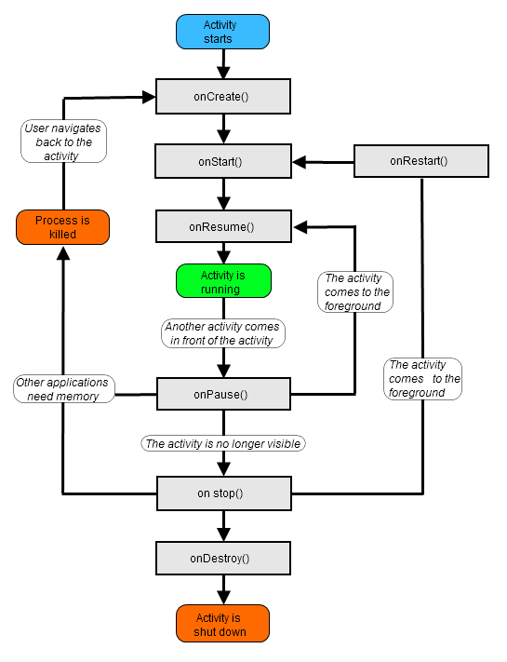

Before the activity runs this 3 methods are activated:

onCraete, onStart, onResume.

The way to kill an activity is with the finish() method. When we call from one activity to another activity, by default the current activity will call her “onPause” activity, so if we will add inside it finish(), the current activity will be killed when the next called activity is shown.

**Printing log messages to the console window:**

**package** com.anna.androidapp;  
  
**import** android.os.Bundle;  
**import** android.support.design.widget.FloatingActionButton;  
**import** android.support.design.widget.Snackbar;  
**import** android.support.v7.app.AppCompatActivity;  
**import** android.support.v7.widget.Toolbar;  
**import** android.view.View;  
**import** android.view.Menu;  
**import** android.view.MenuItem;  
**import** android.util.Log;  
  
*//every activity in android inherits from the Activity (AppCompatActivity inherits Activity)***public class** MainActivity **extends** AppCompatActivity {  
  
 **private static final** String ***TAG*** = **"MyMessage"**;  
  
  
 @Override  
 **protected void** onCreate(Bundle savedInstanceState) {  
 **super**.onCreate(savedInstanceState);  
 setContentView(R.layout.***activity_main***);  
  
 *//to the Log.i we sent 2 parameters: a tag, and the text that we want to print* Log.*i*(***TAG***, **"onCreate"**);  
 }  
  
 @Override  
 **protected void** onStart() {  
 **super**.onStart();  
 Log.*i*(***TAG***, **"onStart"**);  
 }  
  
  
 @Override  
 **protected void** onResume() {  
 **super**.onResume();  
 Log.*i*(***TAG***, **"onResume"**);  
 }  
  
  
 @Override  
 **protected void** onPause() {  
 **super**.onPause();  
 Log.*i*(***TAG***, **"onPause"**);  
 }  
  
  
 @Override  
 **protected void** onStop() {  
 **super**.onStop();  
 Log.*i*(***TAG***, **"onStop"**);  
 }  
  
  
 @Override  
 **protected void** onRestart() {  
 **super**.onRestart();  
 Log.*i*(***TAG***, **"onRestart"**);  
 }  
  
  
 @Override  
 **protected void** onDestroy() {  
 **super**.onDestroy();  
 Log.*i*(***TAG***, **"onDestroy"**);  
 }  
  
  
 @Override  
 **protected void** onSaveInstanceState(Bundle outState) {  
 **super**.onSaveInstanceState(outState);  
 Log.*i*(***TAG***, **"onSaveInstanceState"**);  
 }  
  
  
 @Override  
 **protected void** onRestoreInstanceState(Bundle savedInstanceState) {  
 **super**.onRestoreInstanceState(savedInstanceState);  
 Log.*i*(***TAG***, **"onRestoreInstanceState"**);  
 }  
  
  
 @Override  
 **public boolean** onCreateOptionsMenu(Menu menu) {  
 *// Inflate the menu; this adds items to the action bar if it is present.* getMenuInflater().inflate(R.menu.***menu_main***, menu);  
 **return true**;  
 }  
  
 @Override  
 **public boolean** onOptionsItemSelected(MenuItem item) {  
 *// Handle action bar item clicks here. The action bar will  
 // automatically handle clicks on the Home/Up button, so long  
 // as you specify a parent activity in AndroidManifest.xml.* **int** id = item.getItemId();  
  
 *//noinspection SimplifiableIfStatement* **if** (id == R.id.***action_settings***) {  
 **return true**;  
 }  
  
 **return super**.onOptionsItemSelected(item);  
 }  
}

when we run the application we will see the printed messages in the console window:

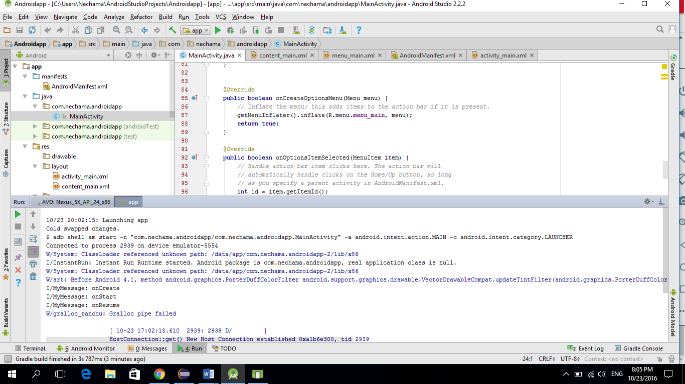

**“string.xml” tools**

When we create our app’s interface, and want to set the text that the user will see, we can just enter the content to the “android:text” attribute of the component.

But a better way to set the text is to declare it in a separate file that is called “string.xml” (is under “res” -> “values”).

In the “string.xml” file we will give each string name and content.

For example: <string name="SignInTitle">Sign In</string>

And in the component’s attribute we will point to this resource in this way:

android:text="@string/SignInTitle"

This is the code for a full app:

|  |
| --- |
| ***** Main Activity.java |
|  | package your.package.name |
|  |  |
|  | import android.support.v7.app.AppCompatActivity; |
|  | import android.os.Bundle; |
|  | import android.view.Menu; |
|  | import android.view.MenuItem; |
|  |  |
|  | public class MainActivity extends AppCompatActivity { |
|  |  |
|  | @Override |
|  | protected void onCreate(Bundle savedInstanceState) { |
|  | super.onCreate(savedInstanceState); |
|  | setContentView(R.layout.activity_main); |
|  | } |
|  |  |
|  | @Override |
|  | public boolean onCreateOptionsMenu(Menu menu) { |
|  | // Inflate the menu; this adds items to the action bar if it is present. |
|  | getMenuInflater().inflate(R.menu.menu_main, menu); |
|  | return true; |
|  | } |
|  |  |
|  | @Override |
|  | public boolean onOptionsItemSelected(MenuItem item) { |
|  | // Handle action bar item clicks here. The action bar will |
|  | // automatically handle clicks on the Home/Up button, so long |
|  | // as you specify a parent activity in AndroidManifest.xml. |
|  | int id = item.getItemId(); |
|  |  |
|  | //noinspection SimplifiableIfStatement |
|  | if (id == R.id.action_settings) { |
|  | return true; |
|  | } |
|  |  |
|  | return super.onOptionsItemSelected(item); |
|  | } |
|  | } |
|  |  |
|  |  |
|  | ***** activity_main.xml |
|  |  |
|  | <RelativeLayout xmlns:android="http://schemas.android.com/apk/res/android" |
|  | xmlns:tools="http://schemas.android.com/tools" android:layout_width="match_parent" |
|  | android:layout_height="match_parent" android:paddingLeft="@dimen/activity_horizontal_margin" |
|  | android:paddingRight="@dimen/activity_horizontal_margin" |
|  | android:paddingTop="@dimen/activity_vertical_margin" |
|  | android:paddingBottom="@dimen/activity_vertical_margin" |
|  | tools:context="glwhitney.info.nbvideos11_12.MainActivity"> |
|  |  |
|  | <TextView |
|  | android:layout_width="wrap_content" |
|  | android:layout_height="wrap_content" |
|  | android:textAppearance="?android:attr/textAppearanceLarge" |
|  | android:text="@string/SignInTitle" |
|  | android:id="@+id/textView" |
|  | android:layout_alignParentTop="true" |
|  | android:layout_alignParentLeft="true" |
|  | android:layout_alignParentStart="true" |
|  | android:singleLine="true"/> |
|  |  |
|  | <EditText |
|  | android:layout_width="wrap_content" |
|  | android:layout_height="wrap_content" |
|  | android:inputType="textEmailAddress" |
|  | android:ems="10" |
|  | android:id="@+id/editText" |
|  | android:layout_below="@+id/textView" |
|  | android:layout_centerHorizontal="true" |
|  | android:layout_marginTop="36dp" |
|  | android:width="320dp"/> |
|  |  |
|  | <EditText |
|  | android:layout_width="wrap_content" |
|  | android:layout_height="wrap_content" |
|  | android:inputType="textPassword" |
|  | android:ems="10" |
|  | android:id="@+id/editText2" |
|  | android:layout_marginTop="45dp" |
|  | android:layout_below="@+id/editText" |
|  | android:layout_alignLeft="@+id/editText" |
|  | android:layout_alignStart="@+id/editText" |
|  | android:width="320dp"/> |
|  |  |
|  | <Button |
|  | android:layout_width="wrap_content" |
|  | android:layout_height="wrap_content" |
|  | android:text="@string/SignInButtonText" |
|  | android:id="@+id/button" |
|  | android:layout_centerVertical="true" |
|  | android:layout_centerHorizontal="true" /> |
|  | </RelativeLayout> |
|  |  |
|  | ***** strings.xml |
|  |  |
|  | <resources> |
|  | <string name="app_name">NB Videos 11_12</string> |
|  | <string name="title_activity_main">MainActivity</string> |
|  |  |
|  |  |
|  | <string name="action_settings">Settings</string> |
|  | <string name="SignInTitle">Sign In</string> |
|  | <string name="SignInButtonText">Log In</string> |
|  | </resources> |

This is the app on runtime:

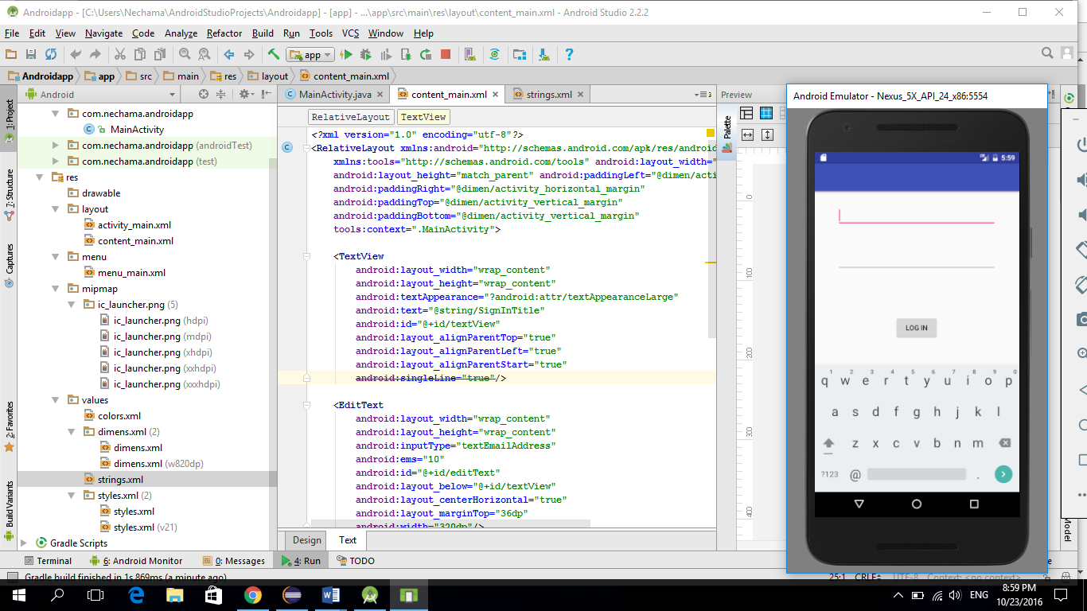

**Creating a EditText with a place holder**

<**EditText**

**android:hint="my text"  
 android:id="@+id/textView6"** />

The EditText will contain by default the “my text” string, that is a place holder, and when the user starts to enter his input, the place holder string disappears.

If the user deleats all the inputthat he

**Creating a user interface by code**

In this example the only code that we have wrote to this app is the following code:

(No xml activity code was edited, everything is with java code)

**package** com.anna.androidapp;  
  
**import** android.os.Bundle;  
**import** android.support.v7.app.AppCompatActivity;  
**import** android.view.Menu;  
**import** android.view.MenuItem;  
**import** android.widget.RelativeLayout;  
**import** android.widget.Button;  
**import** android.graphics.Color;  
**import** android.widget.EditText;  
**import** android.content.res.Resources;  
**import** android.util.TypedValue;  
  
*//every activity in android inherits from the Activity (AppCompatActivity inherits Activity)***public class** MainActivity **extends** AppCompatActivity {  
  
 @Override  
 **protected void** onCreate(Bundle savedInstanceState) {  
 **super**.onCreate(savedInstanceState);  
  
 *//creating a Layout and setting it's background color* RelativeLayout MyLayout = **new** RelativeLayout(**this**);  
 MyLayout.setBackgroundColor(Color.***GREEN***);  
  
 *//creating a Button* Button redButton = **new** Button(**this**);  
 redButton.setText(**"Log In"**);  
 redButton.setBackgroundColor(Color.***RED***);  
  
 *//creating an EditText that will be used to enter input by the user* EditText username = **new** EditText(**this**);  
  
 redButton.setId(1);  
 *//username.setId(2);  
  
 //here we set the height and width of the button and EditText to match their content* RelativeLayout.LayoutParams buttonDetails = **new** RelativeLayout.LayoutParams(  
 RelativeLayout.LayoutParams.***WRAP_CONTENT***,  
 RelativeLayout.LayoutParams.***WRAP_CONTENT*** );  
 RelativeLayout.LayoutParams usernameDetails = **new** RelativeLayout.LayoutParams(  
 RelativeLayout.LayoutParams.***WRAP_CONTENT***,  
 RelativeLayout.LayoutParams.***WRAP_CONTENT*** );  
  
 *//Give rules to position the* usernameDetails.addRule(RelativeLayout.***ABOVE***, redButton.getId());  
 usernameDetails.addRule(RelativeLayout.***CENTER_HORIZONTAL***);  
 usernameDetails.setMargins(0,0,0,50);  
  
 *//Give rules to position the button un the middle of the layout* buttonDetails.addRule(RelativeLayout.***CENTER_HORIZONTAL***);  
 buttonDetails.addRule(RelativeLayout.***CENTER_VERTICAL***);  
  
   
 *//setting the EditText size by dp casted to px ("setWidth" takes only px)* Resources r = getResources();  
 **int** px = (**int**) TypedValue.*applyDimension*(TypedValue.***COMPLEX_UNIT_DIP***,200,  
 r.getDisplayMetrics()  
 );  
  
 username.setWidth(px);  
  
 *//Add widget to layout(button and EditText are now children of layout)* MyLayout.addView(redButton, buttonDetails);  
 MyLayout.addView(username, usernameDetails);  
  
 *//Set the "activity_main" content to the layout that we created here by code* setContentView(MyLayout);  
  
 }  
  
  
 @Override  
 **public boolean** onCreateOptionsMenu(Menu menu) {  
 *// Inflate the menu; this adds items to the action bar if it is present.* getMenuInflater().inflate(R.menu.***menu_main***, menu);  
 **return true**;  
 }  
  
 @Override  
 **public boolean** onOptionsItemSelected(MenuItem item) {  
 *// Handle action bar item clicks here. The action bar will  
 // automatically handle clicks on the Home/Up button, so long  
 // as you specify a parent activity in AndroidManifest.xml.* **int** id = item.getItemId();  
  
 *//noinspection SimplifiableIfStatement* **if** (id == R.id.***action_settings***) {  
 **return true**;  
 }  
  
 **return super**.onOptionsItemSelected(item);  
 }  
}

when we run the app the result will be:

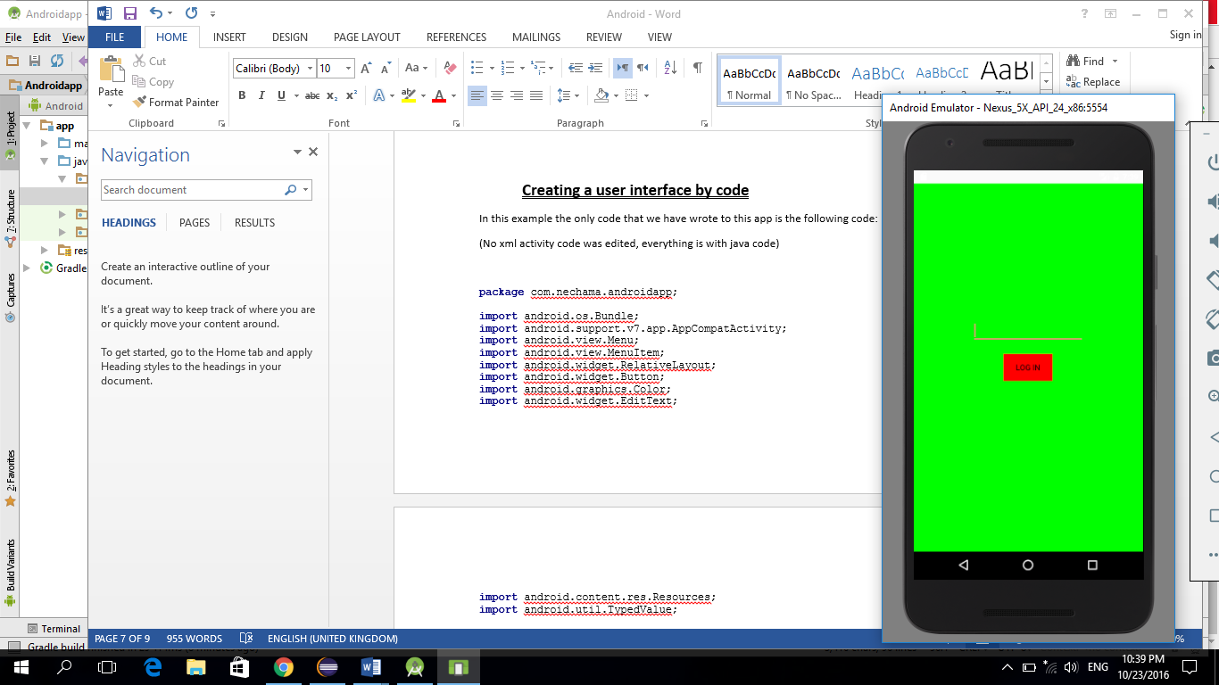

**Add event onclick**

We create a project that onclick will change the button’s default content to different content

**package** com.anna.androidapp;  
  
**import** android.os.Bundle;  
**import** android.support.v7.app.AppCompatActivity;  
**import** android.view.Menu;  
**import** android.view.MenuItem;  
**import** android.widget.Button;  
**import** android.view.View;  
**import** android.widget.TextView;  
  
*//every activity in android inherits from the Activity (AppCompatActivity inherits Activity)***public class** MainActivity **extends** AppCompatActivity {  
  
 @Override  
 **protected void** onCreate(Bundle savedInstanceState) {  
 **super**.onCreate(savedInstanceState);  
 setContentView(R.layout.***activity_main***);  
  
 Button b = (Button)findViewById(R.id.***b***);  
  
 b.setOnClickListener(  
   
*//an event that is activated in a regular click*b.setOnClickListener(  
  
 *//this is the event listner* **new** Button.OnClickListener(){  
  
 *//this is the callback method that will be activated by the event* **public void** onClick(View v){  
 TextView buckysText = (TextView)findViewById(R.id.***b***);  
 buckysText.setText(**"event Done!"**);  
 }  
 }  
);  
*//an event that is activated in a long click (in a long click event we must to return a bool value)*b.setOnLongClickListener(  
 **new** Button.OnLongClickListener(){  
 **public boolean** onLongClick(View v){  
 TextView buckysText = (TextView)findViewById(R.id.***b***);  
 buckysText.setText(**"long click!"**);  
   
 *//whenever we return true in a long click event, the callback function will be activated* **return true**;  
 }  
 }  
);

}  
  
  
 @Override  
 **public boolean** onCreateOptionsMenu(Menu menu) {  
 *// Inflate the menu; this adds items to the action bar if it is present.* getMenuInflater().inflate(R.menu.***menu_main***, menu);  
 **return true**;  
 }  
  
 @Override  
 **public boolean** onOptionsItemSelected(MenuItem item) {  
 *// Handle action bar item clicks here. The action bar will  
 // automatically handle clicks on the Home/Up button, so long  
 // as you specify a parent activity in AndroidManifest.xml.* **int** id = item.getItemId();  
  
 *//noinspection SimplifiableIfStatement* **if** (id == R.id.***action_settings***) {  
 **return true**;  
 }  
  
 **return super**.onOptionsItemSelected(item);  
 }  
}

The app activity before clicking the button:

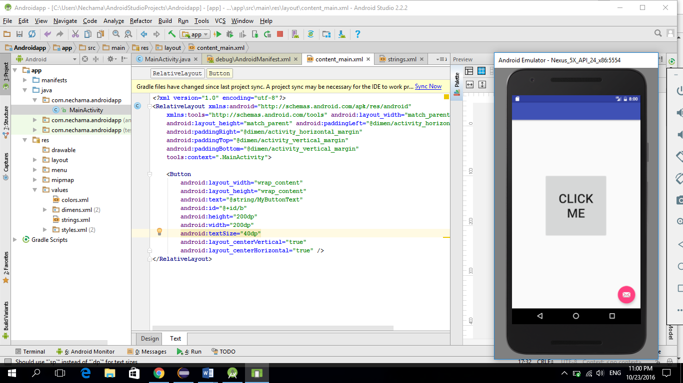

The app activity after clicking the button:

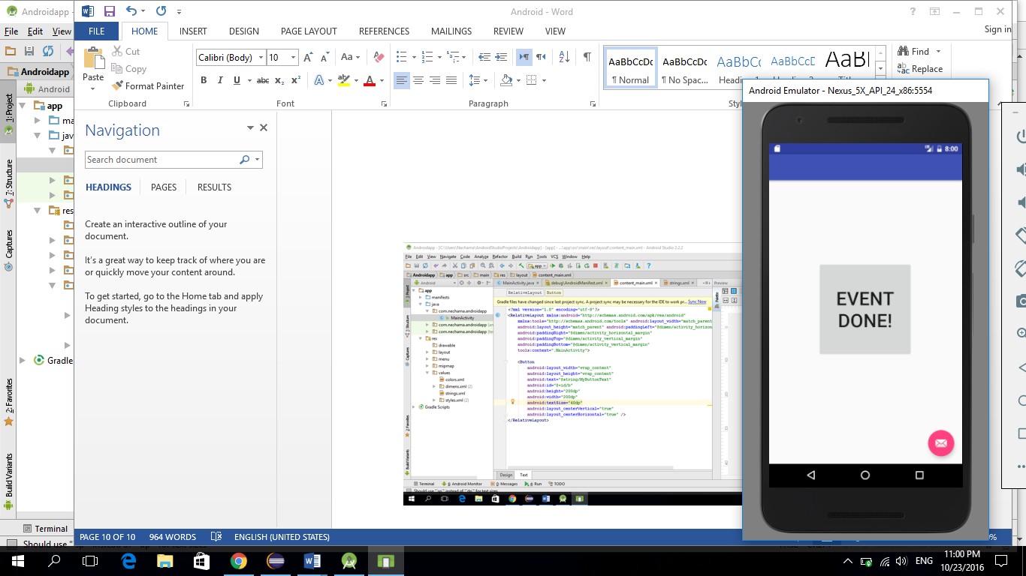

The app activity after a long click on the button:

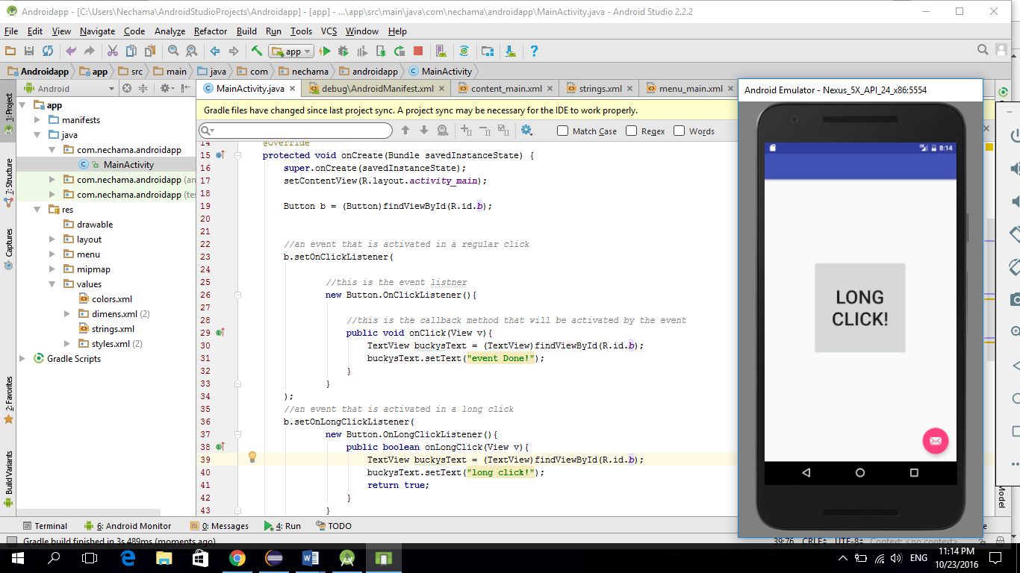

**Gesture events**

Gesture events are different touch screen events, in this app we changed the textview content in every event to a different content.

**package** com.anna.androidapp;  
  
**import** android.os.Bundle;  
**import** android.support.v7.app.AppCompatActivity;  
**import** android.view.Menu;  
**import** android.view.MenuItem;  
**import** android.widget.TextView;  
**import** android.view.MotionEvent;  
**import** android.view.GestureDetector;  
**import** android.support.v4.view.GestureDetectorCompat;  
  
*//every activity in android inherits from the Activity (AppCompatActivity inherits Activity)  
//for every Gesture event we have to implement a special matching interface***public class** MainActivity **extends** AppCompatActivity **implements** GestureDetector.OnGestureListener,  
GestureDetector.OnDoubleTapListener {  
 **private** TextView **t**;  
 **private** GestureDetectorCompat **gestureDetector**;  
  
 @Override  
 **protected void** onCreate(Bundle savedInstanceState) {  
 **super**.onCreate(savedInstanceState);  
 setContentView(R.layout.***activity_main***);  
  
 **t** = (TextView) findViewById(R.id.***t***);  
 **this**.**gestureDetector** = **new** GestureDetectorCompat(**this**, **this**);  
 **gestureDetector**.setOnDoubleTapListener(**this**);  
 }  
  
 *///////// OnGestureListener METHODS //////////* @Override  
 **public boolean** onSingleTapConfirmed(MotionEvent e) {  
 **t**.setText(**"onSingleTapConfirmed"**);  
 **return true**;  
 }  
  
 @Override  
 **public boolean** onDoubleTap(MotionEvent e) {  
 **t**.setText(**"onDoubleTap"**);  
 **return true**;  
 }  
  
 @Override  
 **public boolean** onDoubleTapEvent(MotionEvent e) {  
 **t**.setText(**"onDoubleTapEvent"**);  
 **return true**;  
 }  
  
 @Override  
 **public boolean** onDown(MotionEvent e) {  
 **t**.setText(**"onDown"**);  
 **return true**;  
 }  
  
 @Override  
 **public void** onShowPress(MotionEvent e) {  
 **t**.setText(**"onShowPress"**);  
  
 }  
  
 @Override  
 **public boolean** onSingleTapUp(MotionEvent e) {  
 **t**.setText(**"onSingleTapUp"**);  
 **return true**;  
 }  
  
 @Override  
 **public boolean** onScroll(MotionEvent e1, MotionEvent e2, **float** distanceX, **float** distanceY) {  
 **t**.setText(**"onScroll"**);  
 **return true**;  
 }  
  
 @Override  
 **public void** onLongPress(MotionEvent e) {  
 **t**.setText(**"onLongPress"**);  
  
 }  
  
 @Override  
 **public boolean** onFling(MotionEvent e1, MotionEvent e2, **float** velocityX, **float** velocityY) {  
 **t**.setText(**"onFling"**);  
 **return true**;  
 }  
  
 *///////// OnDoubleTapListener METHODS //////////* @Override  
 **public boolean** onTouchEvent(MotionEvent event) {  
 **this**.**gestureDetector**.onTouchEvent(event);  
 **return super**.onTouchEvent(event);  
 }  
  
 @Override  
 **public boolean** onCreateOptionsMenu(Menu menu) {  
 *// Inflate the menu; this adds items to the action bar if it is present.* getMenuInflater().inflate(R.menu.***menu_main***, menu);  
 **return true**;  
 }  
  
 @Override  
 **public boolean** onOptionsItemSelected(MenuItem item) {  
 *// Handle action bar item clicks here. The action bar will  
 // automatically handle clicks on the Home/Up button, so long  
 // as you specify a parent activity in AndroidManifest.xml.* **int** id = item.getItemId();  
  
 *//noinspection SimplifiableIfStatement* **if** (id == R.id.***action_settings***) {  
 **return true**;  
 }  
  
 **return super**.onOptionsItemSelected(item);  
 }  
 }

the default activity

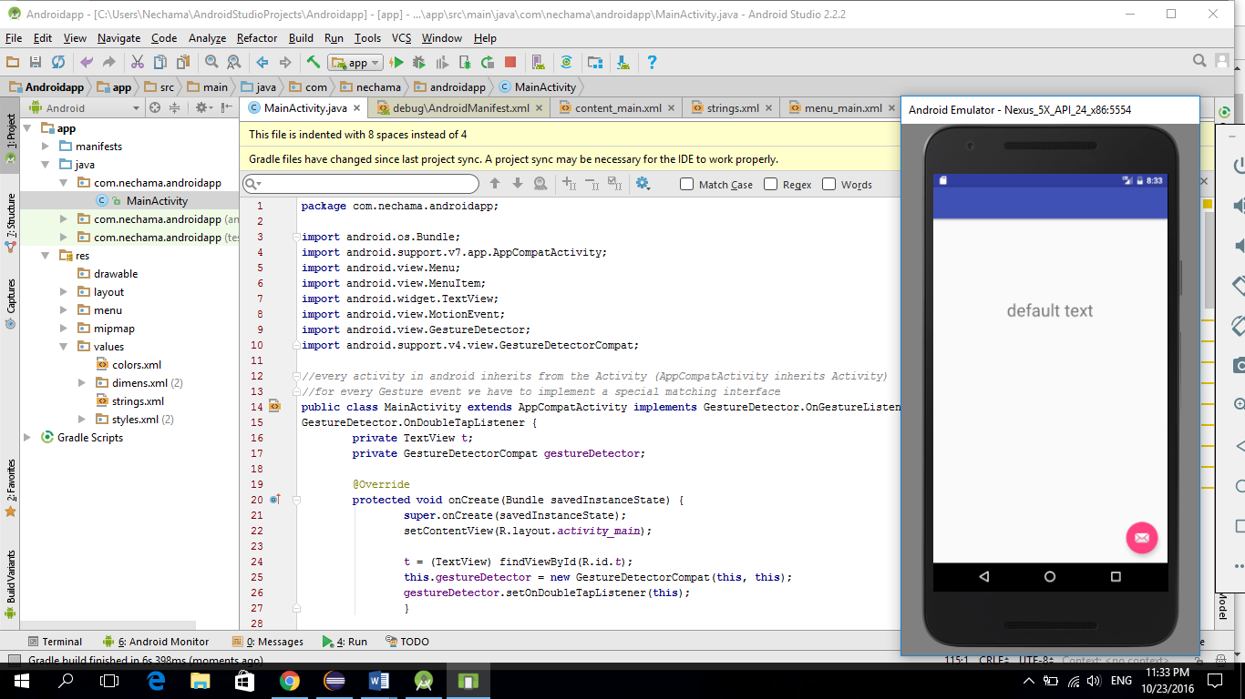

The activity while scrolling the screen:

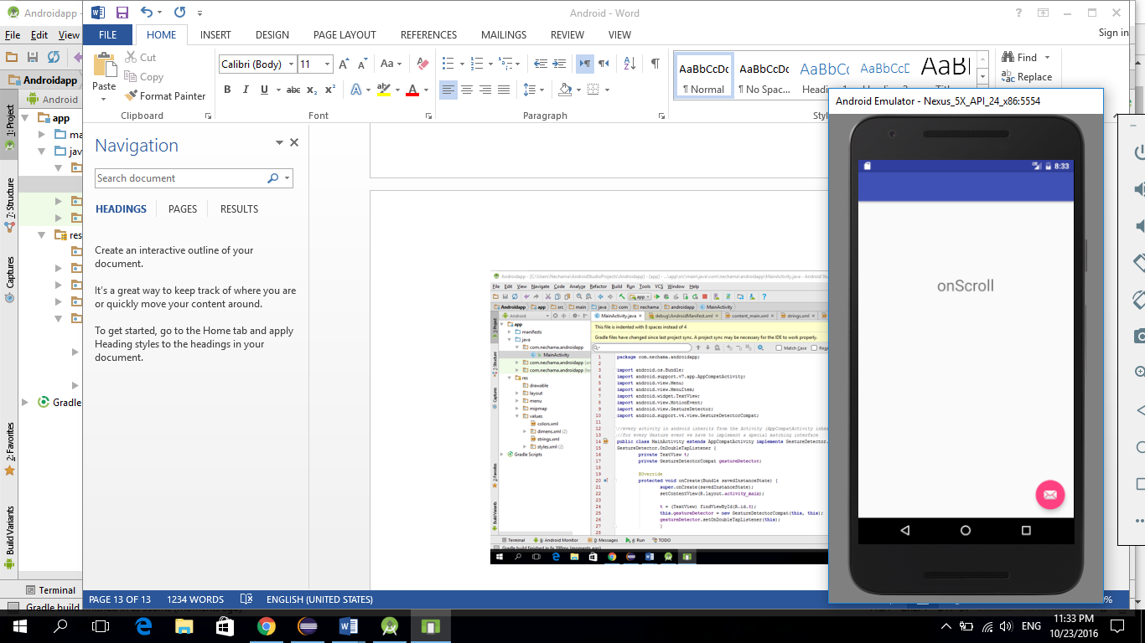

The activity while clicking on the screen:

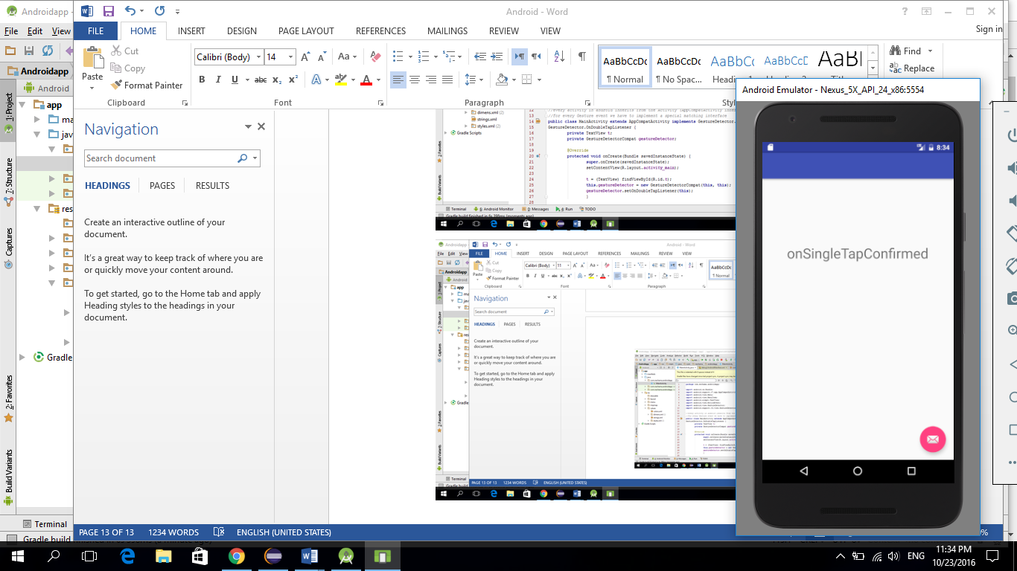

**Fragments**

The way to create a part of an activity in a separate class, in order to enable using this part in different activities in our project, without having to copy the part inside each activity.

(We can even use multiple fragments in one activity).

In this app we used images, and the way to add images to an android project is:

First we need to change our files window view option to the “project” option

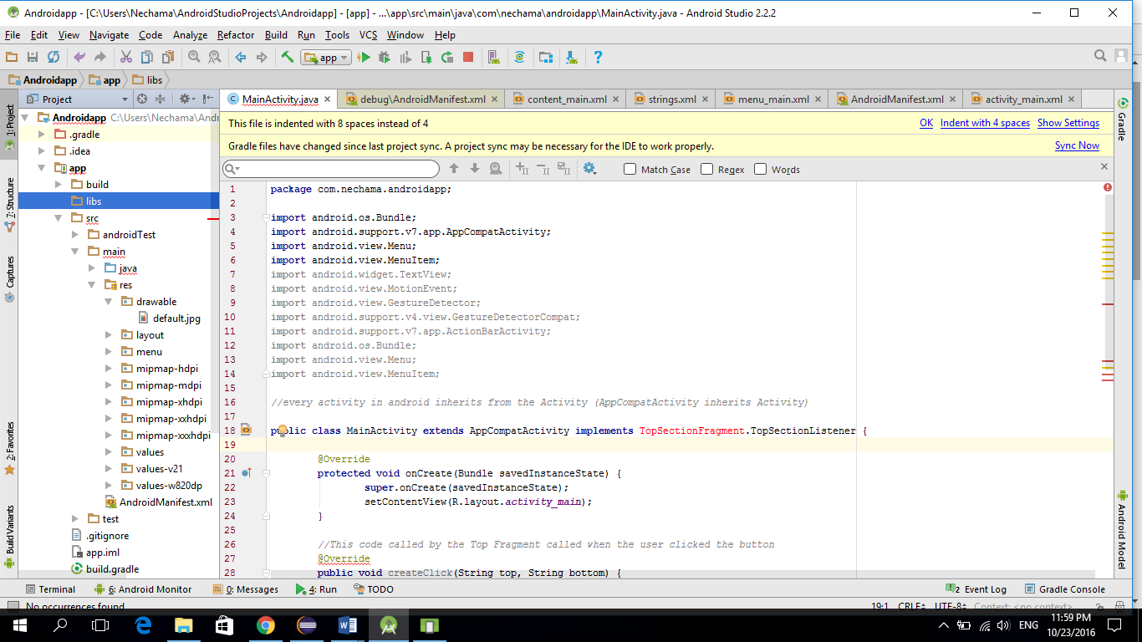

Then we need to find the “res” file

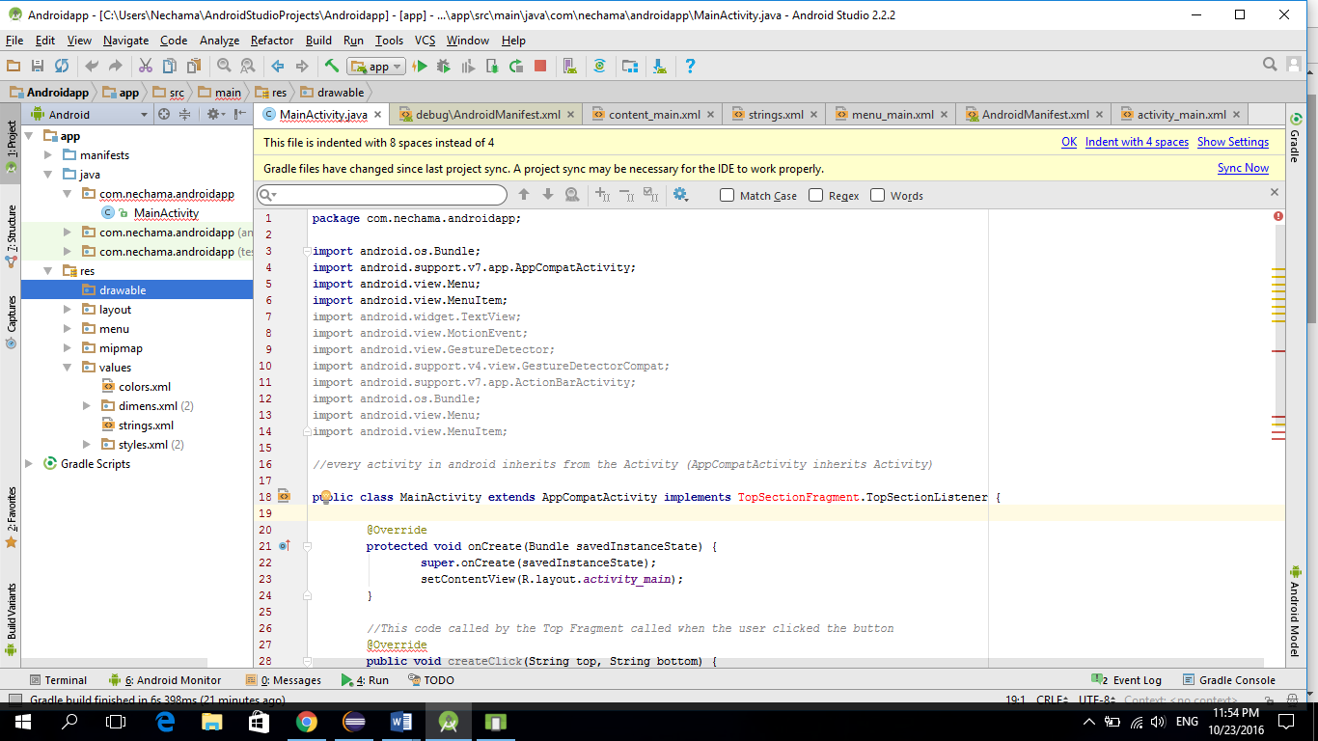

The last step is dragging the wanted image into the “drawable” directory. (the image name has to be created only with lower case chars, and an underscore), in the xml file we can accesses the image in the following syntax: @ drawable/ the image name (without extension)

Creating fragment:

Every fragment is created with 2 different parts:

1. the class part - will contain the functional logic (this class must extend Fragment class)
2. the activity interface - an xml file (right click in the “layout” area-> new -> layout resource file).

After everything is done, we want to add the fragment to the main_activity. We can do it by writing the matching attribute inside the xml file, or by the designer - dragg this option:

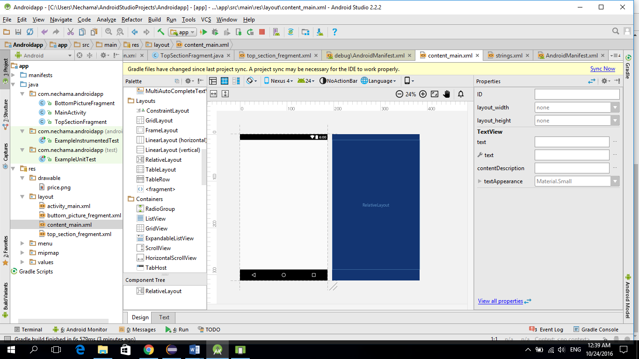

Then selecting the fragment that we want to add, from a special window that will appear.

* Important:

One fragment can’t communicate directly with other fragment, and the only way to communicate between them is trough the activity that contains both fragments.

**Fragments full example:**

In this example we created 2 fragments, and one main activity that contains both fragments.

The first fragment - Top section fragment:

Contains two edit boxes and one button

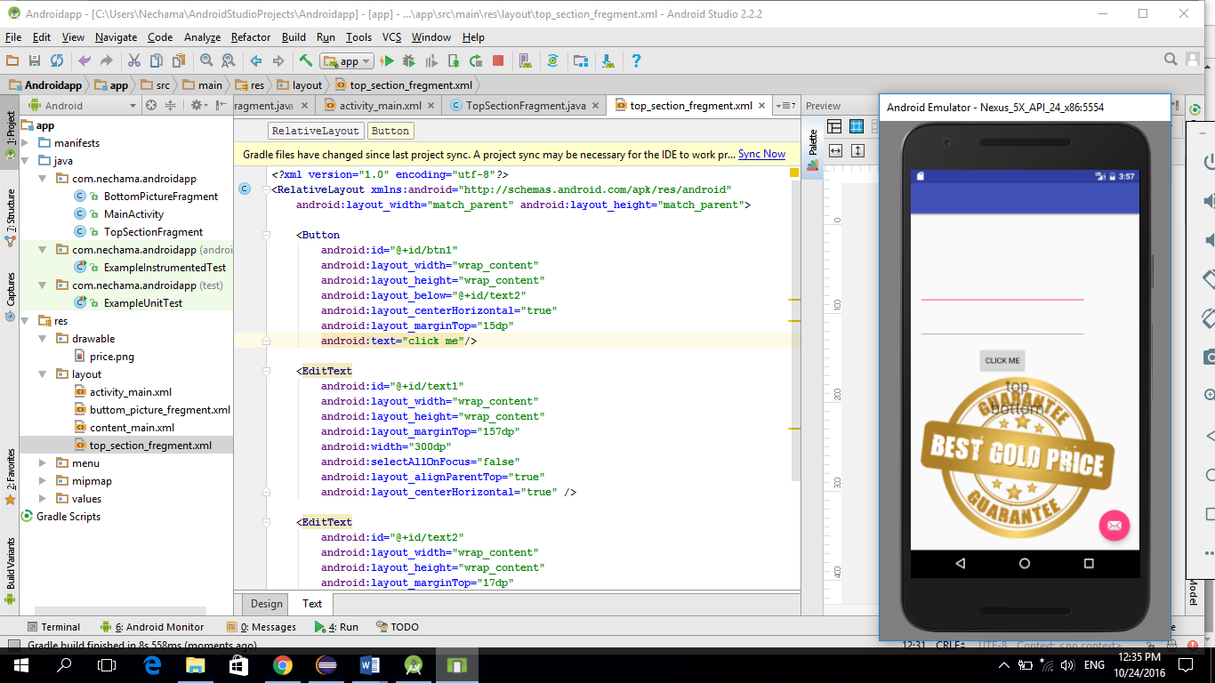

The second fragment - Bottom section fragment:

Contains an image that is the fragment’s background, and two text boxes that their default content is: top, bottom.



The main activity:

Contains both fragments.

By default will be:



Every time the user enters in the Top fragment’s edit boxes two strings, and clicks on the button, the content of the Bottom fragment’s text boxes will be changed to the new entered strings.

Before click: after click:

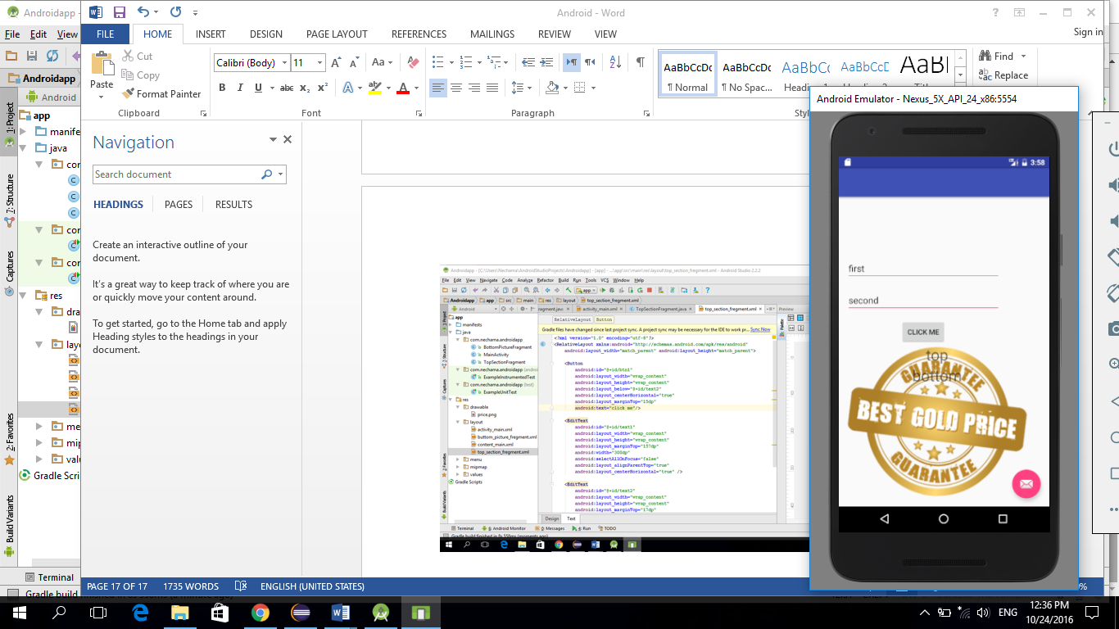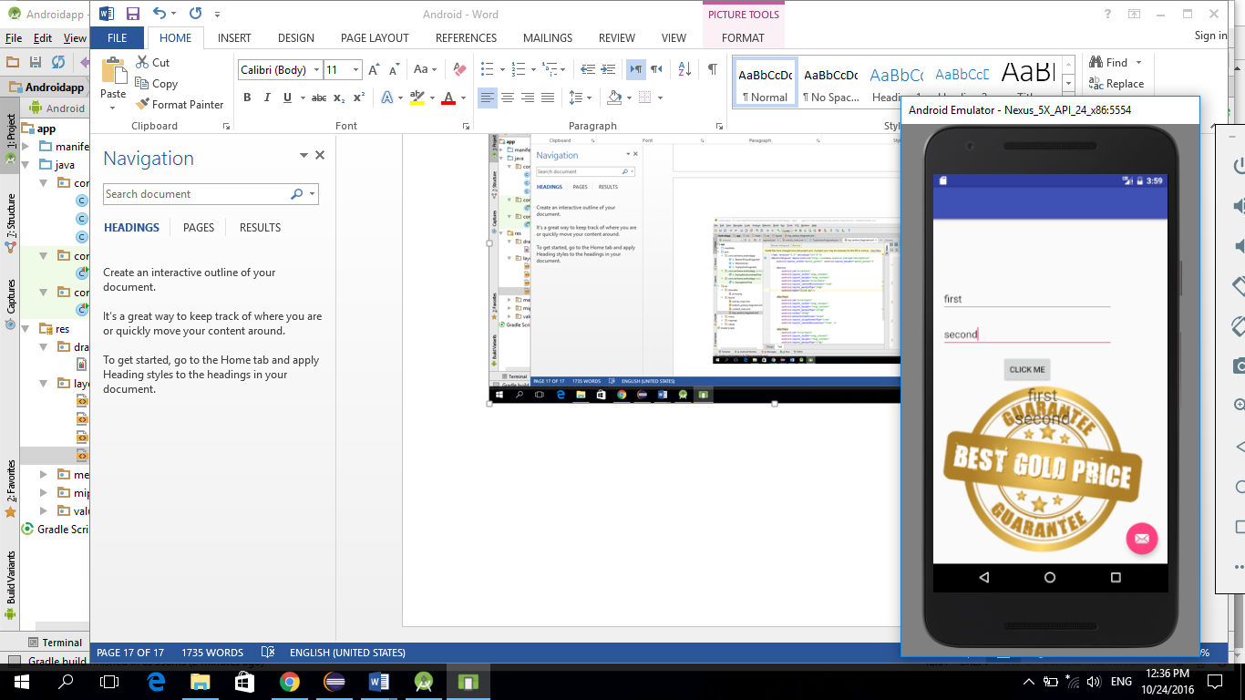

**Main activity:**

Class code:

**package** com.anna.androidapp;  
  
**import** android.os.Bundle;  
**import** android.support.v7.app.AppCompatActivity;  
**import** android.view.Menu;  
**import** android.view.MenuItem;  
  
  
*//every activity in android inherits from the Activity (AppCompatActivity inherits Activity)***public class** MainActivity **extends** AppCompatActivity **implements** TopSectionFragment.TopSectionListener {  
  
 @Override  
 **protected void** onCreate(Bundle savedInstanceState) {  
 **super**.onCreate(savedInstanceState);  
 setContentView(R.layout.***activity_main***);  
 }  
  
 *//This code is called by the Top Fragment when the user clicked the button  
 //this function implements the TopSectionListener interface* @Override  
 **public void** createClick(String top, String bottom) {  
 BottomPictureFragment bottomFragment = (BottomPictureFragment)getSupportFragmentManager().findFragmentById(R.id.***fragment2***);  
 bottomFragment.setClickedText(top, bottom);  
 }  
  
 @Override  
 **public boolean** onCreateOptionsMenu(Menu menu) {  
 *// Inflate the menu; this adds items to the action bar if it is present.* getMenuInflater().inflate(R.menu.***menu_main***, menu);  
 **return true**;  
 }  
  
 @Override  
 **public boolean** onOptionsItemSelected(MenuItem item) {  
 *// Handle action bar item clicks here. The action bar will  
 // automatically handle clicks on the Home/Up button, so long  
 // as you specify a parent activity in AndroidManifest.xml.* **int** id = item.getItemId();  
  
 *//noinspection SimplifiableIfStatement* **if** (id == R.id.***action_settings***) {  
 **return true**;  
 }  
  
 **return super**.onOptionsItemSelected(item);  
 }  
  
}

activity xml:

*<?***xml version="1.0" encoding="utf-8"***?>*<**RelativeLayout xmlns:android="http://schemas.android.com/apk/res/android"  
 xmlns:tools="http://schemas.android.com/tools" android:layout_width="match_parent"  
 android:layout_height="match_parent" android:paddingLeft="@dimen/activity_horizontal_margin"  
 android:paddingRight="@dimen/activity_horizontal_margin"  
 android:paddingTop="@dimen/activity_vertical_margin"  
 android:paddingBottom="@dimen/activity_vertical_margin"  
 tools:context=".MainActivity"**>  
  
  
 <**fragment  
 android:layout_width="match_parent"  
 android:layout_height="10px"  
  
 android:name="com.anna.androidapp.BottomPictureFragment"  
 android:layout_marginRight="26dp"  
 android:id="@+id/fragment2"  
 tools:layout="@layout/buttom_picture_fregment"  
 android:layout_below="@+id/fragment"  
 android:layout_alignParentBottom="true"** />  
  
 <**fragment  
 android:layout_width="wrap_content"  
 android:layout_height="wrap_content"  
 android:name="com.anna.androidapp.TopSectionFragment"  
 android:id="@+id/fragment"  
 tools:layout="@layout/top_section_fregment"  
 android:layout_alignParentTop="true"** />  
</**RelativeLayout**>

**Top section fragment:**

Class code:

**package** com.anna.androidapp;  
  
**import** android.os.Bundle;  
**import** android.support.annotation.Nullable;  
**import** android.support.v4.app.Fragment;  
**import** android.view.LayoutInflater;  
**import** android.view.View;  
**import** android.view.ViewGroup;  
**import** android.app.Activity;  
**import** android.widget.Button;  
**import** android.widget.EditText;  
  
**public class** TopSectionFragment **extends** Fragment {  
  
 **private static** EditText *etTopTextInput*;  
 **private static** EditText *etBottomTextInput*;  
  
  
 *//an property of the inner interface* TopSectionListener **activityCommander**;  
  
  
 *//an inner interface that is used to force the activity that will use this class, to implement the createClick function* **public interface** TopSectionListener{  
 **public void** createClick(String top, String bottom);  
 }  
  
  
 *//this function is activated each time this fregment is attached to an activity  
 //in this function we get the interface that the activity created* @Override  
 **public void** onAttach(Activity activity) {  
 **super**.onAttach(activity);  
 **try**{  
 **activityCommander** = (TopSectionListener) activity;  
 }**catch** (ClassCastException e){  
 **throw new** ClassCastException(activity.toString());  
 }  
 }  
  
 @Override  
 **public** View onCreateView(LayoutInflater inflater, @Nullable ViewGroup container, @Nullable Bundle savedInstanceState) {  
 View = inflater.inflate(R.layout.***top_section_fregment***, container, **false**);  
  
 *etTopTextInput* = (EditText)view. findViewById(R.id.***text1***);  
 *etBottomTextInput* = (EditText)view.findViewById(R.id.***text2***);  
  
 **final** Button = (Button)view.findViewById(R.id.***btn1***);  
  
 button.setOnClickListener(  
 **new** View.OnClickListener(){  
  
 @Override  
 **public void** onClick(View v) {  
 buttonClicked(v);  
 }  
 }  
 );  
  
 **return** view;  
 }  
  
 *//Calls this when button clicked* **public void** buttonClicked(View view){  
 **activityCommander**.createClick(*etTopTextInput*.getText().toString(), *etBottomTextInput*.getText().toString());  
 }  
}

activity xml:

*<?***xml version="1.0" encoding="utf-8"***?>*<**RelativeLayout xmlns:android="http://schemas.android.com/apk/res/android"  
 android:layout_width="match_parent" android:layout_height="match_parent"**>  
  
 <**Button  
 android:id="@+id/btn1"  
 android:layout_width="wrap_content"  
 android:layout_height="wrap_content"  
 android:layout_below="@+id/text2"  
 android:layout_centerHorizontal="true"  
 android:layout_marginTop="15dp"  
 android:text="click me"**/>  
  
 <**EditText  
 android:id="@+id/text1"  
 android:layout_width="wrap_content"  
 android:layout_height="wrap_content"  
 android:layout_marginTop="157dp"  
 android:width="300dp"  
 android:selectAllOnFocus="false"  
 android:layout_alignParentTop="true"  
 android:layout_centerHorizontal="true"** />  
  
 <**EditText  
 android:id="@+id/text2"  
 android:layout_width="wrap_content"  
 android:layout_height="wrap_content"  
 android:layout_marginTop="17dp"  
 android:width="300dp"  
 android:layout_below="@+id/text1"  
 android:layout_alignLeft="@+id/text1"  
 android:layout_alignStart="@+id/text1"** />  
</**RelativeLayout**>

**Bottom section fragment:**

Class code:

**package** com.anna.androidapp;  
  
**import** android.os.Bundle;  
**import** android.support.annotation.Nullable;  
**import** android.support.v4.app.Fragment;  
**import** android.view.LayoutInflater;  
**import** android.view.View;  
**import** android.view.ViewGroup;  
**import** android.widget.TextView;  
  
  
**public class** BottomPictureFragment **extends** Fragment {  
  
 **private static** TextView *txtTop*;  
 **private static** TextView *txtBottom*;  
  
 @Override  
 **public** View onCreateView(LayoutInflater inflater, @Nullable ViewGroup container, @Nullable Bundle savedInstanceState) {  
 View view = inflater.inflate(R.layout.***buttom_picture_fregment***, container, **false**);  
 *txtTop* = (TextView)view.findViewById(R.id.***txtTop***);  
 *txtBottom* = (TextView)view.findViewById(R.id.***txtBottom***);  
 **return** view;  
 }  
  
 **public void** setClickedText(String top, String bottom){  
 *txtTop*.setText(top);  
 *txtBottom*.setText(bottom);  
 }  
  
}

activity xml:

*<?***xml version="1.0" encoding="utf-8"***?>*<**LinearLayout xmlns:android="http://schemas.android.com/apk/res/android"  
 android:orientation="vertical" android:layout_width="match_parent"  
 android:layout_height="match_parent"  
 android:background="@drawable/price"**>  
  
 <**TextView  
  
 android:text="top"  
 android:textSize="30dp"  
 android:gravity="center_horizontal"  
 android:layout_width="match_parent"  
 android:layout_height="wrap_content"  
 android:id="@+id/txtTop"** />  
  
 <**TextView  
 android:text="bottom"  
 android:textSize="30dp"  
 android:gravity="center_horizontal"  
 android:layout_width="match_parent"  
 android:layout_height="wrap_content"  
  
 android:id="@+id/txtBottom"** />  
</**LinearLayout**>

**Creating a flow menu:**

Open a new project and choose this layout:

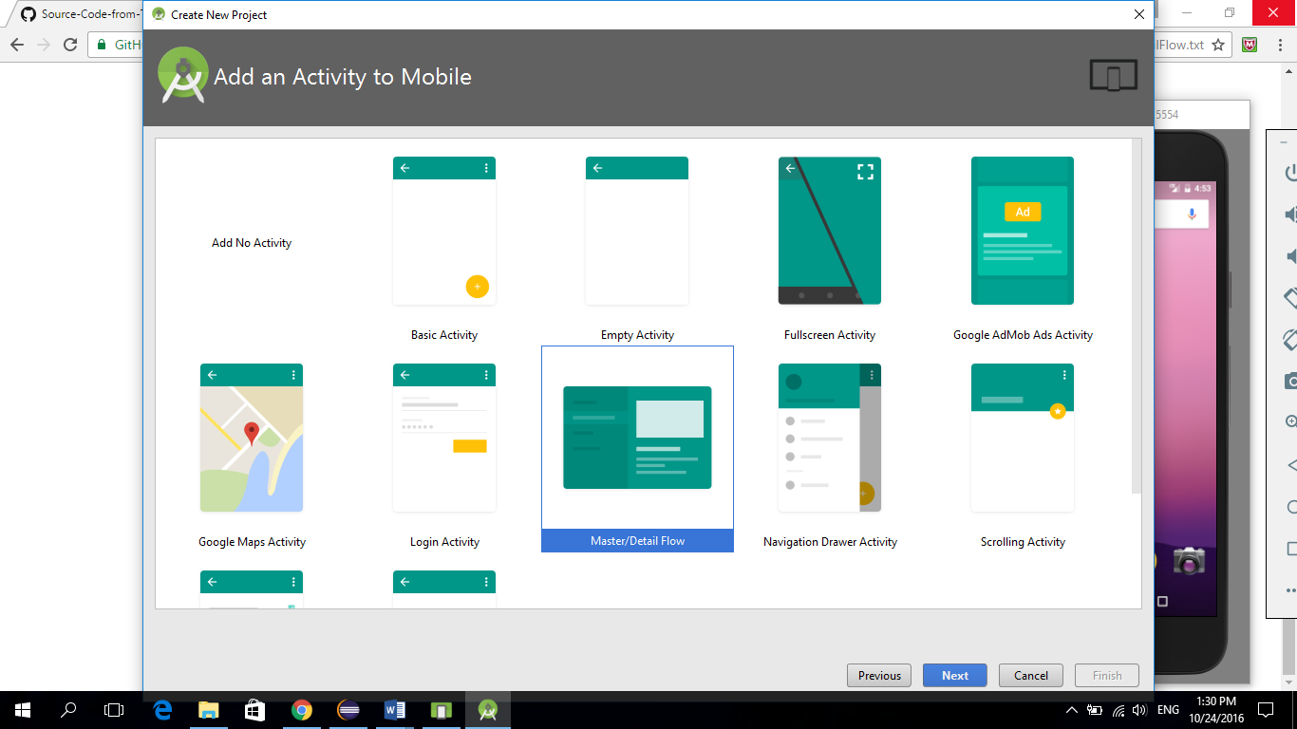

Then the new project will have one java class to the mainActivity, and two xml files to the activity_main and the menu.

The following code creates an app that contains a flow menu with color options, and sets the main activities background to the checked color.

The default app activity:

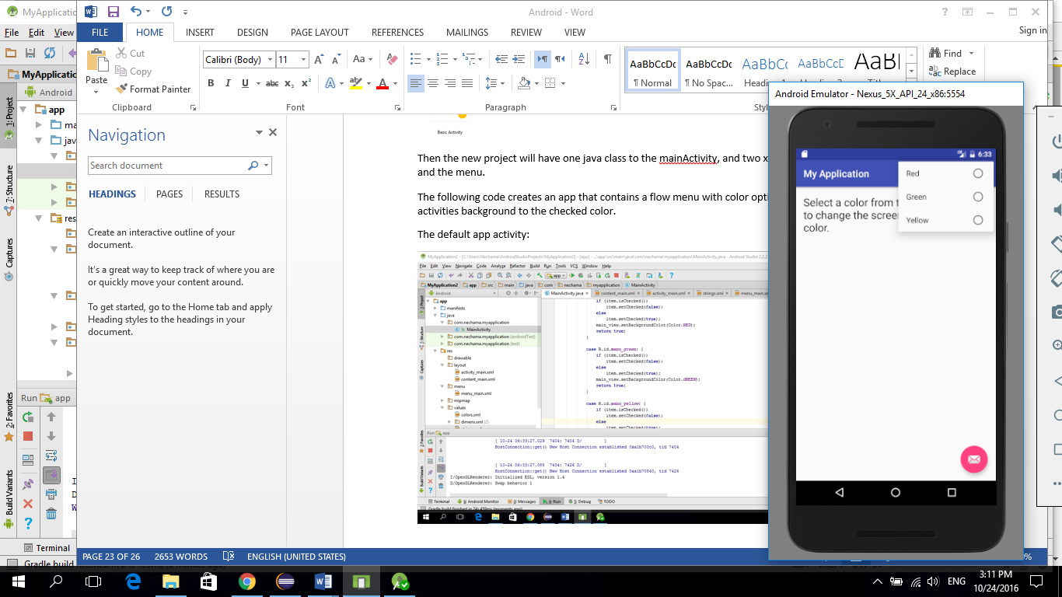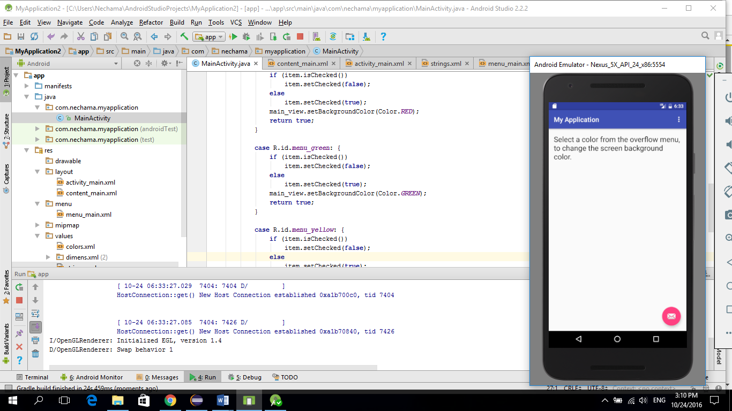

The app activity after selecting the green option:

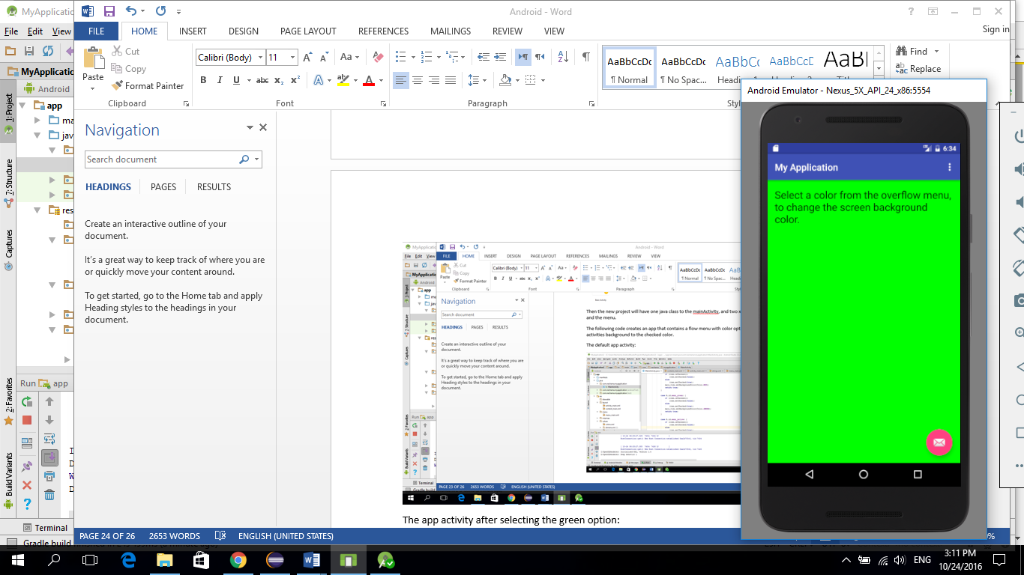

**mainActivity class:**

**package** com.anna.myapplication;  
  
**import** android.os.Bundle;  
**import** android.support.design.widget.FloatingActionButton;  
**import** android.support.design.widget.Snackbar;  
**import** android.support.v7.app.AppCompatActivity;  
**import** android.support.v7.widget.Toolbar;  
**import** android.view.View;  
**import** android.view.Menu;  
**import** android.view.MenuItem;  
**import** android.graphics.Color;  
**import** android.widget.RelativeLayout;  
  
  
**public class** MainActivity **extends** AppCompatActivity {  
  
 @Override  
 **protected void** onCreate(Bundle savedInstanceState) {  
 **super**.onCreate(savedInstanceState);  
 setContentView(R.layout.***activity_main***);  
 Toolbar toolbar = (Toolbar) findViewById(R.id.***toolbar***);  
 setSupportActionBar(toolbar);  
  
 FloatingActionButton fab = (FloatingActionButton) findViewById(R.id.***fab***);  
 fab.setOnClickListener(**new** View.OnClickListener() {  
 @Override  
 **public void** onClick(View view) {  
 Snackbar.*make*(view, **"Replace with your own action"**, Snackbar.***LENGTH_LONG***)  
 .setAction(**"Action"**, **null**).show();  
 }  
 });  
 }  
  
 @Override  
 **public boolean** onCreateOptionsMenu(Menu menu) {  
 *// Inflate the menu; this adds items to the action bar if it is present.* getMenuInflater().inflate(R.menu.***menu_main***, menu);  
 **return true**;  
 }  
  
 @Override  
 **public boolean** onOptionsItemSelected(MenuItem item) {  
 RelativeLayout main_view = (RelativeLayout) findViewById(R.id.***content_main***);  
 **switch** (item.getItemId()) {  
 **case** R.id.***menu_red***: {  
 **if** (item.isChecked())  
 item.setChecked(**false**);  
 **else** item.setChecked(**true**);  
 main_view.setBackgroundColor(Color.***RED***);  
 **return true**;  
 }  
  
 **case** R.id.***menu_green***: {  
 **if** (item.isChecked())  
 item.setChecked(**false**);  
 **else** item.setChecked(**true**);  
 main_view.setBackgroundColor(Color.***GREEN***);  
 **return true**;  
 }  
  
 **case** R.id.***menu_yellow***: {  
 **if** (item.isChecked())  
 item.setChecked(**false**);  
 **else** item.setChecked(**true**);  
 main_view.setBackgroundColor(Color.***YELLOW***);  
 **return true**;  
 }  
  
 **default**:  
 **return super**.onOptionsItemSelected(item);  
 }  
 }  
}

**activity_main xml:**

*<?***xml version="1.0" encoding="utf-8"***?>*<**RelativeLayout xmlns:android="http://schemas.android.com/apk/res/android"  
 xmlns:app="http://schemas.android.com/apk/res-auto"  
 xmlns:tools="http://schemas.android.com/tools"  
 android:id="@+id/content_main"  
 android:layout_width="match_parent"  
 android:layout_height="match_parent"  
 android:paddingBottom="@dimen/activity_vertical_margin"  
 android:paddingLeft="@dimen/activity_horizontal_margin"  
 android:paddingRight="@dimen/activity_horizontal_margin"  
 android:paddingTop="@dimen/activity_vertical_margin"  
 app:layout_behavior="@string/appbar_scrolling_view_behavior"  
 tools:context="com.anna.myapplication.MainActivity"  
 tools:showIn="@layout/activity_main"**>  
  
  
 <**TextView  
 android:layout_width="wrap_content"  
 android:layout_height="wrap_content"  
 android:textAppearance="?android:attr/textAppearanceLarge"  
 android:text="@string/tvInstructions"  
 android:id="@+id/tvInstructions"  
 android:layout_alignParentTop="true"  
 android:layout_alignParentLeft="true"  
 android:layout_alignParentStart="true"** />  
</**RelativeLayout**>

**Menu_main xml:**

<**menu xmlns:android="http://schemas.android.com/apk/res/android"  
 xmlns:app="http://schemas.android.com/apk/res-auto"  
 xmlns:tools="http://schemas.android.com/tools"  
 tools:context=".MainActivity"** >  
<**group android:checkableBehavior="single"**>  
<**item  
 android:id="@+id/menu_red"  
 android:orderInCategory="1"  
 app:showAsAction="never"  
 android:title="@string/strRed"**/>  
  
<**item  
 android:id="@+id/menu_green"  
 android:orderInCategory="2"  
 app:showAsAction="never"  
 android:title="@string/strGreen"**/>  
  
<**item  
 android:id="@+id/menu_yellow"  
 android:orderInCategory="3"  
 app:showAsAction="never"  
 android:title="@string/strYellow"**/>  
</**group**>  
  
 </**menu**>

**Transitions**

To create the next project, we need to create a minimum 19 version (KitKat version).

The project shows by default a button in the top left side, and by clicking on the screen the button will resize to a bigger size, and remove to the bottom right side.

Default layout:

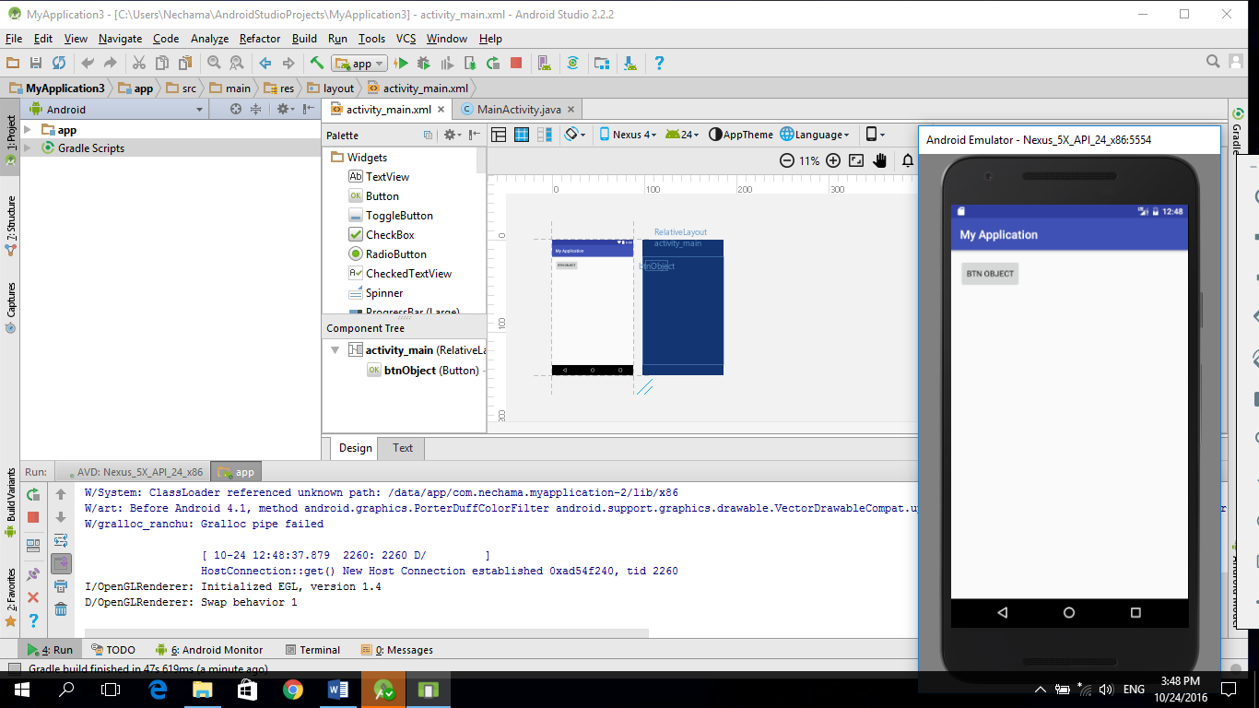

After clicking:

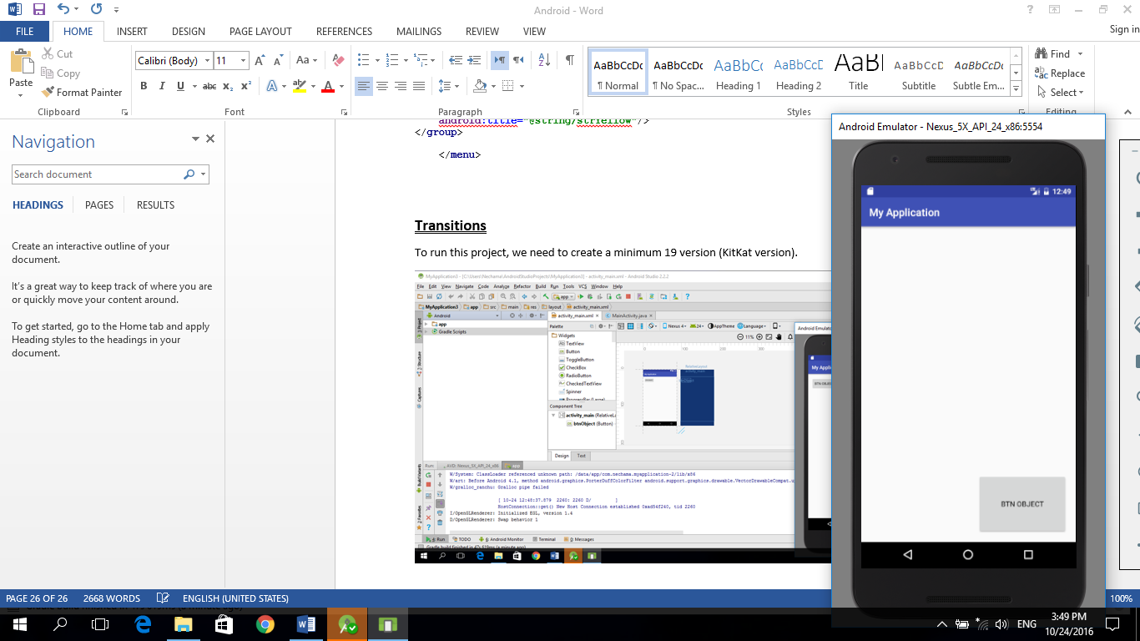

**MainActivity file:**

**package** com.anna.myapplication;  
  
**import** android.support.v7.app.AppCompatActivity;  
**import** android.os.Bundle;  
**import** android.transition.TransitionManager;  
**import** android.view.MotionEvent;  
**import** android.view.View;  
**import** android.view.ViewGroup;  
**import** android.widget.RelativeLayout;  
  
**public class** MainActivity **extends** AppCompatActivity {  
  
 ViewGroup **rlParent**;  
 @Override  
 **protected void** onCreate(Bundle savedInstanceState) {  
 **super**.onCreate(savedInstanceState);  
 setContentView(R.layout.***activity_main***);  
  
 **rlParent** = (ViewGroup)findViewById(R.id.***activity_main***);  
 **rlParent**.setOnTouchListener(  
 **new** RelativeLayout.OnTouchListener() {  
 @Override  
 **public boolean** onTouch(View v, MotionEvent event) {  
 moveButton();  
 **return true**;  
 }  
 }  
 );  
 }  
  
 **public void** moveButton(){  
 View btnObject = findViewById(R.id.***btnObject***);  
 TransitionManager.*beginDelayedTransition*(**rlParent**);  
  
 *// Change the position of the button* RelativeLayout.LayoutParams positionRules = **new** RelativeLayout.LayoutParams(  
 RelativeLayout.LayoutParams.***WRAP_CONTENT***, RelativeLayout.LayoutParams.***WRAP_CONTENT***);  
 positionRules.addRule(RelativeLayout.***ALIGN_PARENT_BOTTOM***, RelativeLayout.***TRUE***);  
 positionRules.addRule(RelativeLayout.***ALIGN_PARENT_RIGHT***, RelativeLayout.***TRUE***);  
 btnObject.setLayoutParams(positionRules);  
  
 *//Change the size of the button* ViewGroup.LayoutParams sizeRules = btnObject.getLayoutParams();  
 sizeRules.**width** = 450;  
 sizeRules.**height**= 300;  
 btnObject.setLayoutParams(sizeRules);  
 }  
  
  
  
  
  
}

**Layout file:**

*<?***xml version="1.0" encoding="utf-8"***?>*<**RelativeLayout xmlns:android="http://schemas.android.com/apk/res/android"  
 xmlns:tools="http://schemas.android.com/tools"  
 android:id="@+id/activity_main"  
 android:layout_width="match_parent"  
 android:layout_height="match_parent"  
 android:paddingBottom="@dimen/activity_vertical_margin"  
 android:paddingLeft="@dimen/activity_horizontal_margin"  
 android:paddingRight="@dimen/activity_horizontal_margin"  
 android:paddingTop="@dimen/activity_vertical_margin"  
 tools:context="com.anna.myapplication.MainActivity"**>  
  
  
 <**Button  
 android:layout_width="wrap_content"  
 android:layout_height="wrap_content"  
 android:text="@string/btn_object"  
 android:id="@+id/btnObject"  
 android:layout_alignParentTop="true"  
 android:layout_alignParentStart="true"** />  
</**RelativeLayout**>

**Intent**

Intent- having few activities in one app, and switching between them.

Adding a new activity to an existing project:

Right click on the “app” directory ->new -> activity -> empty activity

A window with the new activity settings will appear, and we can choose names to the xml file, and the class file.

Important: if it’s not the main activity the “” option must be unchecked.

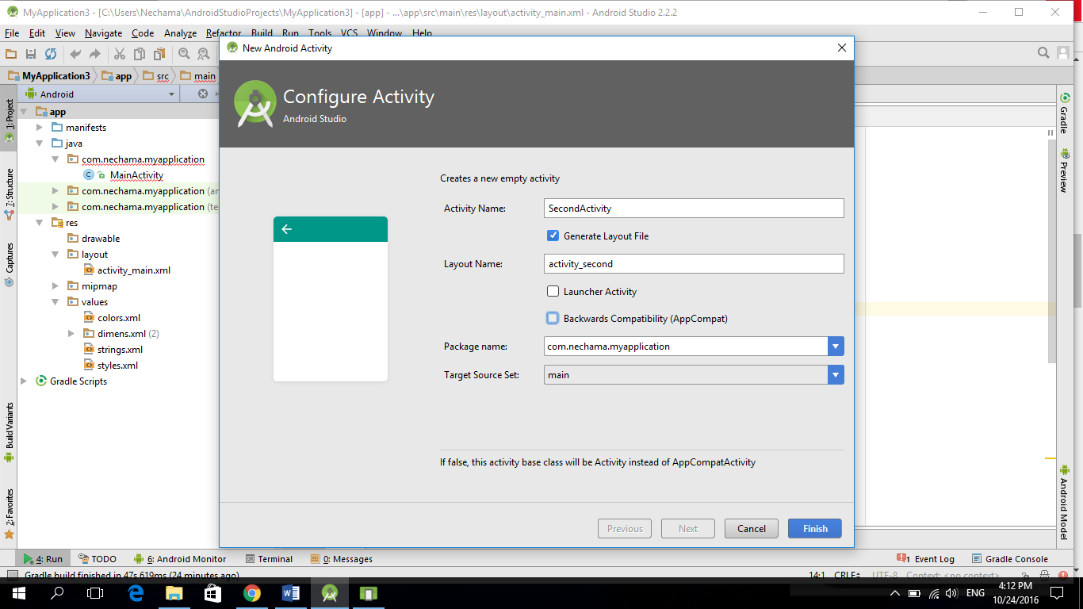

In the next example, we created two activities:

1. main activity- contains a Edit text to enter string, and a button to move to the second activity
2. second activity- contains a text box, and a button to move to the Main activity

The text box in the second activity, will contain the string that the user entered in the Main activity’s edit box.

The default activity:

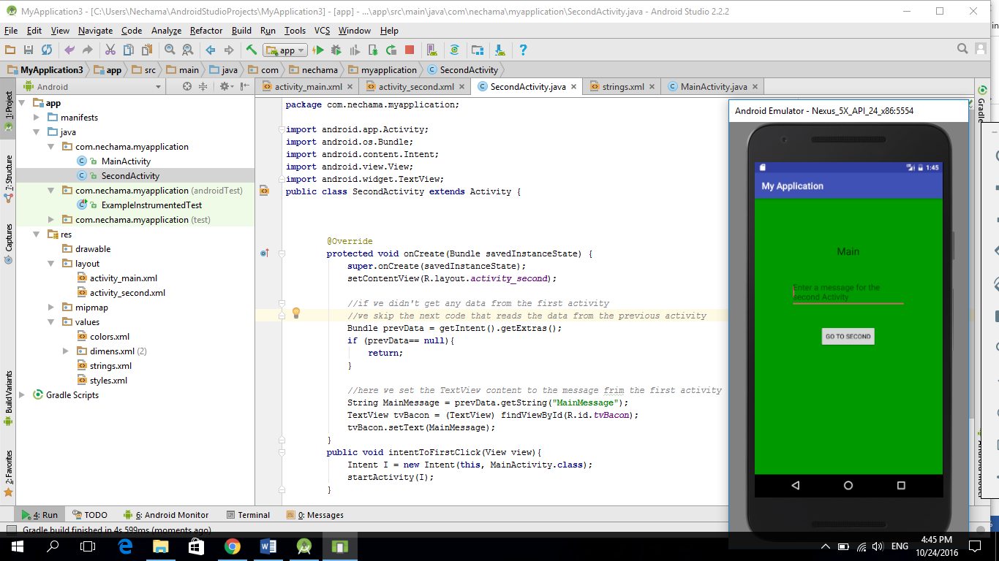

Main activity after entering input:

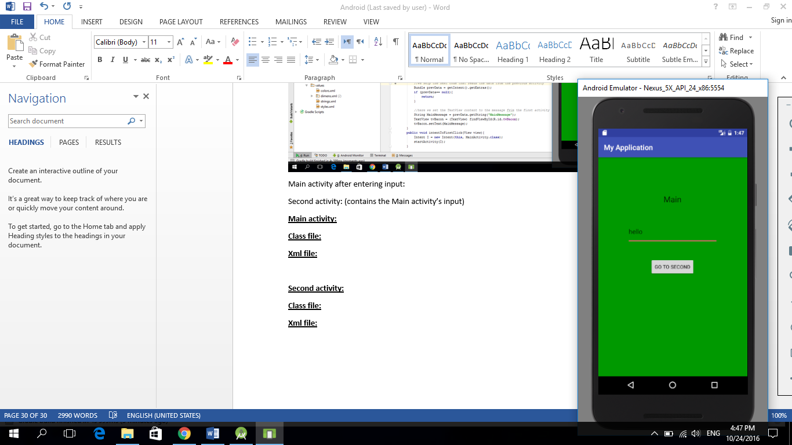

Second activity: (contains the Main activity’s input)

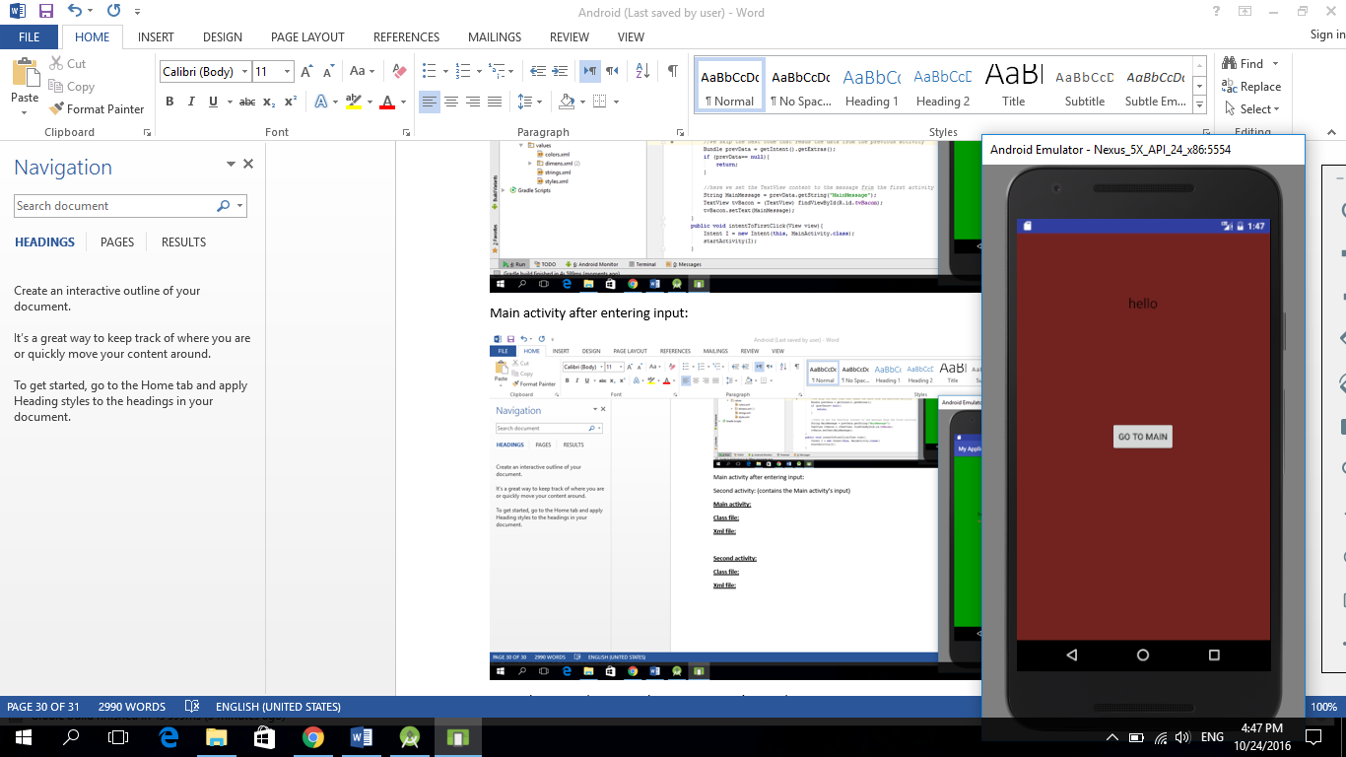

**Main activity:**

**Class file:**

**package** com.anna.myapplication;  
  
**import** android.support.v7.app.AppCompatActivity;  
**import** android.os.Bundle;;  
**import** android.view.View;  
**import** android.content.Intent;  
**import** android.widget.EditText;  
  
  
**public class** MainActivity **extends** AppCompatActivity {  
  
  
 @Override  
 **protected void** onCreate(Bundle savedInstanceState) {  
 **super**.onCreate(savedInstanceState);  
 setContentView(R.layout.***activity_main***);  
 }  
  
 **public void** intentToSecondClick(View view){  
 *//this is the way to switch between activities* Intent I = **new** Intent(**this**, SecondActivity.**class**);  
 *// get user input from main activity* **final** EditText userInput = (EditText) findViewById(R.id.***ptvUserInput***);  
 String userMessage = userInput.getText().toString();  
  
 *// pass user input in the intent to the second activity  
 //the first parameter is the key to this message. and the second parameter is the value* I.putExtra(**"MainMessage"**, userMessage);  
  
 startActivity(I);  
 }  
  
  
 }

**Xml file:**

*<?***xml version="1.0" encoding="utf-8"***?>*<**RelativeLayout xmlns:android="http://schemas.android.com/apk/res/android"  
 xmlns:tools="http://schemas.android.com/tools"  
 android:id="@+id/activity_main"  
 android:layout_width="match_parent"  
 android:layout_height="match_parent"  
 android:paddingBottom="@dimen/activity_vertical_margin"  
 android:paddingLeft="@dimen/activity_horizontal_margin"  
 android:paddingRight="@dimen/activity_horizontal_margin"  
 android:paddingTop="@dimen/activity_vertical_margin"  
 android:background="#009900"  
 tools:context="com.anna.myapplication.MainActivity"**>  
  
  
  
 <**TextView  
 android:layout_width="wrap_content"  
 android:layout_height="wrap_content"  
 android:textAppearance="?android:attr/textAppearanceLarge"  
 android:text="@string/tvApplesText"  
 android:id="@+id/tvApples"  
 android:layout_alignParentTop="true"  
 android:layout_centerHorizontal="true"  
 android:layout_marginTop="84dp"** />  
  
 <**Button  
 android:layout_width="wrap_content"  
 android:layout_height="wrap_content"  
 android:text="@string/btnBacon"  
 android:id="@+id/btnBacon"  
 android:layout_centerVertical="true"  
 android:layout_centerHorizontal="true"  
 android:onClick="intentToSecondClick"**/>  
  
 <**EditText  
 android:layout_width="wrap_content"  
 android:layout_height="wrap_content"  
 android:id="@+id/ptvUserInput"  
 android:layout_below="@+id/tvApples"  
 android:layout_marginTop="42dp"  
 android:width="250dp"  
 android:layout_centerHorizontal="true"  
 android:hint="Enter a message for the second Activity"** />  
  
</**RelativeLayout**>

**Second activity:**

**Class file:**

**package** com.anna.myapplication;  
  
**import** android.app.Activity;  
**import** android.os.Bundle;  
**import** android.content.Intent;  
**import** android.view.View;  
**import** android.widget.TextView;  
**public class** SecondActivity **extends** Activity {  
  
  
  
 @Override  
 **protected void** onCreate(Bundle savedInstanceState) {  
 **super**.onCreate(savedInstanceState);  
 setContentView(R.layout.***activity_second***);  
  
 *//if we didn't get any data from the first activity  
 //we skip the next code that reads the data from the previous activity* Bundle prevData = getIntent().getExtras();  
 **if** (prevData== **null**){  
 **return**;  
 }  
  
 *//here we set the TextView content to the message frim the first activity* String MainMessage = prevData.getString(**"MainMessage"**);  
 TextView tvBacon = (TextView) findViewById(R.id.***tvBacon***);  
 tvBacon.setText(MainMessage);  
 }  
 **public void** intentToFirstClick(View view){  
 Intent I = **new** Intent(**this**, MainActivity.**class**);

*//startActivity method takes the intent that we want to be the activity*  
 startActivity(I);  
 }  
  
  
  
}

**Xml file:**

*<?***xml version="1.0" encoding="utf-8"***?>*<**RelativeLayout xmlns:android="http://schemas.android.com/apk/res/android"  
 xmlns:tools="http://schemas.android.com/tools"  
 android:id="@+id/activity_second"  
 android:layout_width="match_parent"  
 android:layout_height="match_parent"  
 android:paddingBottom="@dimen/activity_vertical_margin"  
 android:paddingLeft="@dimen/activity_horizontal_margin"  
 android:paddingRight="@dimen/activity_horizontal_margin"  
 android:paddingTop="@dimen/activity_vertical_margin"  
 tools:context="com.anna.myapplication.SecondActivity"  
 android:background="#72231f"**>  
  
  
 <**TextView  
 android:layout_width="wrap_content"  
 android:layout_height="wrap_content"  
 android:textAppearance="?android:attr/textAppearanceLarge"  
 android:text="@string/tvBacon"  
 android:id="@+id/tvBacon"  
 android:layout_marginTop="82dp"  
 android:singleLine="true"  
 android:layout_alignParentTop="true"  
 android:layout_centerHorizontal="true"** />  
  
 <**Button  
 android:layout_width="wrap_content"  
 android:layout_height="wrap_content"  
 android:text="@string/btnApplesText"  
 android:id="@+id/btnApples"  
 android:layout_centerVertical="true"  
 android:layout_centerHorizontal="true"  
 android:onClick="intentToFirstClick"** />  
</**RelativeLayout**>

**Resources: (string.xml)**

<**resources**>  
 <**string name="app_name"**>My Application</**string**>  
 <**string name="action_settings"**>Settings</**string**>  
 <**string name="tvApplesText"**>Main</**string**>  
 <**string name="btnBacon"**>Go To Second</**string**>  
 <**string name="title_activity_bacon"**>Bacon</**string**>  
 <**string name="tvBacon"**>Second</**string**>  
 <**string name="btnApplesText"**>Go To Main</**string**>  
</**resources**>

**Creating a broadcast app between two different projects:**

1. **first project:**

We created a simple project with a class and activity. The activity has a button that onclick activates the function that sends broadcast data.

Class code:

**package** com.example.anna.myapplication;  
  
**import** android.support.v7.app.AppCompatActivity;  
**import** android.os.Bundle;  
**import** android.content.Intent;  
**import** android.view.View;  
  
  
  
**public class** MainActivity **extends** AppCompatActivity {  
  
  
 @Override  
 **protected void** onCreate(Bundle savedInstanceState) {  
 **super**.onCreate(savedInstanceState);  
 setContentView(R.layout.***activity_main***);  
 }  
  
 **public void** sendBroadcast(View view){  
  
 *//setting an Intent that doesn't get a class as a parameter, because he sends brodcast to everyone that listens* Intent i = **new** Intent();  
  
 *//here we set the key of this Broadcast sender with the package name* i.setAction(**"com.example.anna.myapplication"**);  
  
  
 *//adding support to all android versions* i.addFlags(Intent.***FLAG_INCLUDE_STOPPED_PACKAGES***);  
 sendBroadcast(i);  
 }  
  
  
  
 }

xml file:

*<?***xml version="1.0" encoding="utf-8"***?>*<**RelativeLayout xmlns:android="http://schemas.android.com/apk/res/android"  
 xmlns:tools="http://schemas.android.com/tools"  
 android:id="@+id/activity_main"  
 android:layout_width="match_parent"  
 android:layout_height="match_parent"  
 android:paddingBottom="@dimen/activity_vertical_margin"  
 android:paddingLeft="@dimen/activity_horizontal_margin"  
 android:paddingRight="@dimen/activity_horizontal_margin"  
 android:paddingTop="@dimen/activity_vertical_margin"  
 tools:context="com.example.anna.myapplication.MainActivity"**>  
  
  
 <**Button  
 android:text="send Broadcast"  
 android:layout_width="wrap_content"  
 android:layout_height="wrap_content"  
 android:layout_marginTop="125dp"  
 android:id="@+id/button2"  
 android:onClick="sendBroadcast"  
 tools:ignore="HardcodedText"** />  
  
  
  
  
</**RelativeLayout**>

1. **Second project:**

We created a new project, and selected the “no activity” option.

In the Project window we added a class in the directory that holds all the java classes, by clicking right click on this directory, and then:

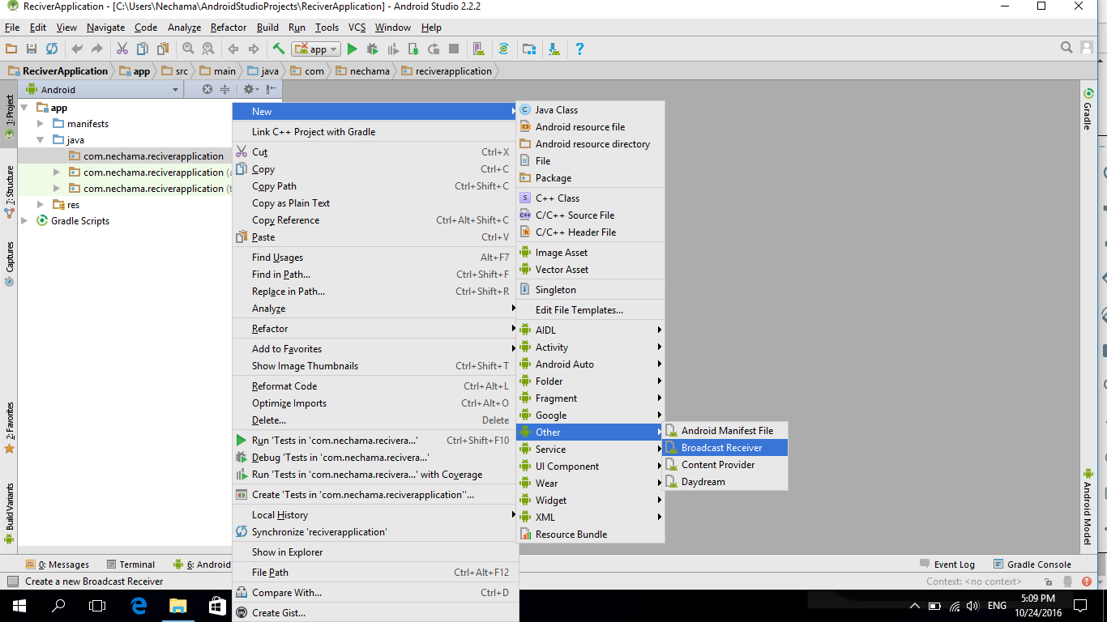

In the class we edited the following code:

**package** com.anna.reciverapplication;  
  
**import** android.content.BroadcastReceiver;  
**import** android.content.Context;  
**import** android.content.Intent;  
**import** android.widget.Toast;  
  
**public class** MyReceiver **extends** BroadcastReceiver {  
 **public** MyReceiver() {  
 }  
  
 *//this function is executed when this app receives brodcast* @Override  
 **public void** onReceive(Context context, Intent intent) {  
  
 *//the "Toast.makeText" function shows a popup message to the screen  
 //the 3 parameters that we send are:context, the string that will be the message, and the length that this popup will be shown* Toast.*makeText*(context,**"bradcost has been recived"**,Toast.***LENGTH_LONG***).show();  
 }  
}

in the manifest we added the receiver configurations:

*<?***xml version="1.0" encoding="utf-8"***?>*<**manifest xmlns:android="http://schemas.android.com/apk/res/android"  
 package="com.anna.reciverapplication"**>  
  
 <**application  
 android:allowBackup="true"  
 android:icon="@mipmap/ic_launcher"  
 android:label="@string/app_name"  
 android:supportsRtl="true"  
 android:theme="@style/AppTheme"**>  
 <**receiver  
 android:name=".MyReceiver"  
 android:enabled="true"  
 android:exported="true"**>  
this <**intent-filter**>  
 we <**action android:name="com.example.anna.myapplication"**></**action**> added </**intent-filter**>  
 </**receiver**>  
 </**application**>  
  
</**manifest**>

**Running the Receiver app:**

Because this project don’t have any activity, before running it we have to set the “lunch” option to “nothing”

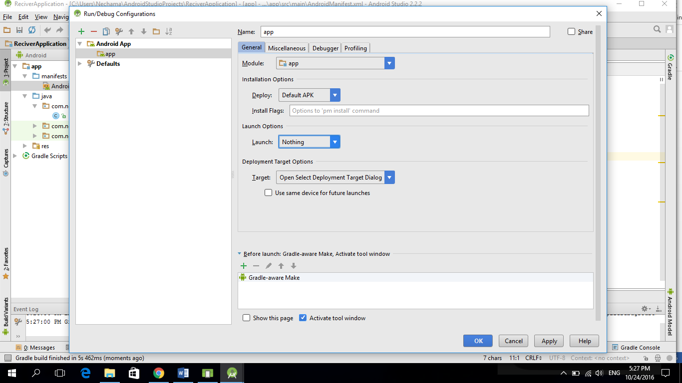

Then we can run the app and the result will be:

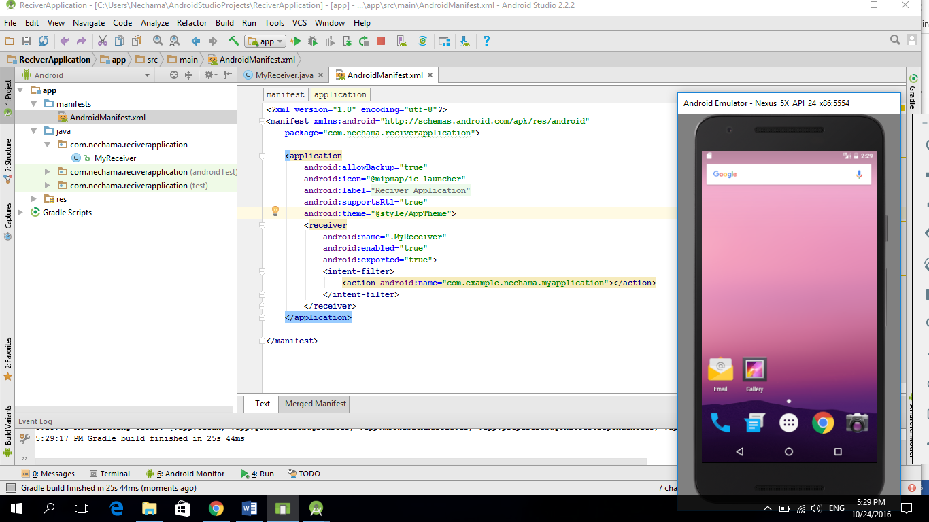

**Running the sender app:**

This project contains an activity, and we will run it normally, on the same emulator that the receiver is running.

The result will be: After clicking the button:

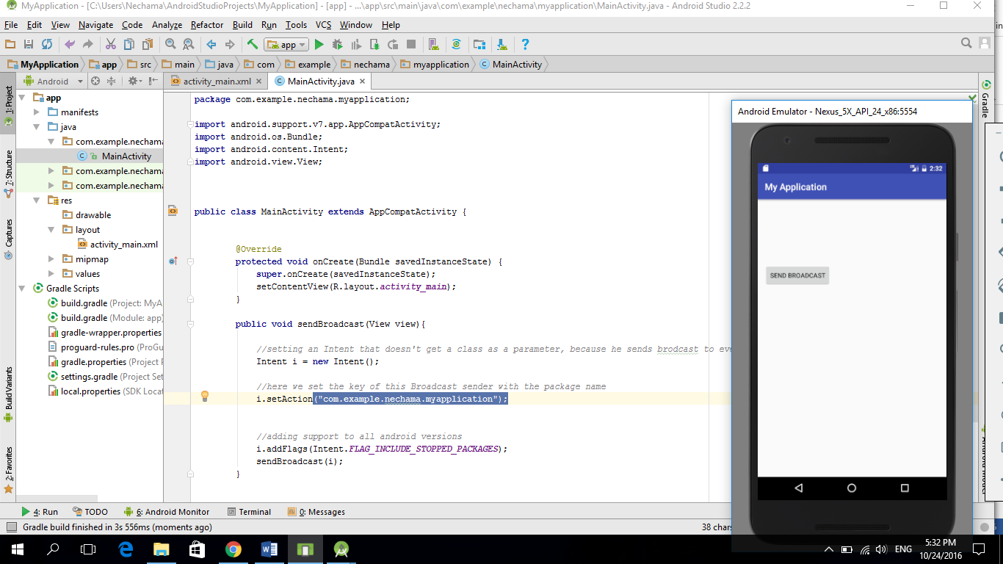 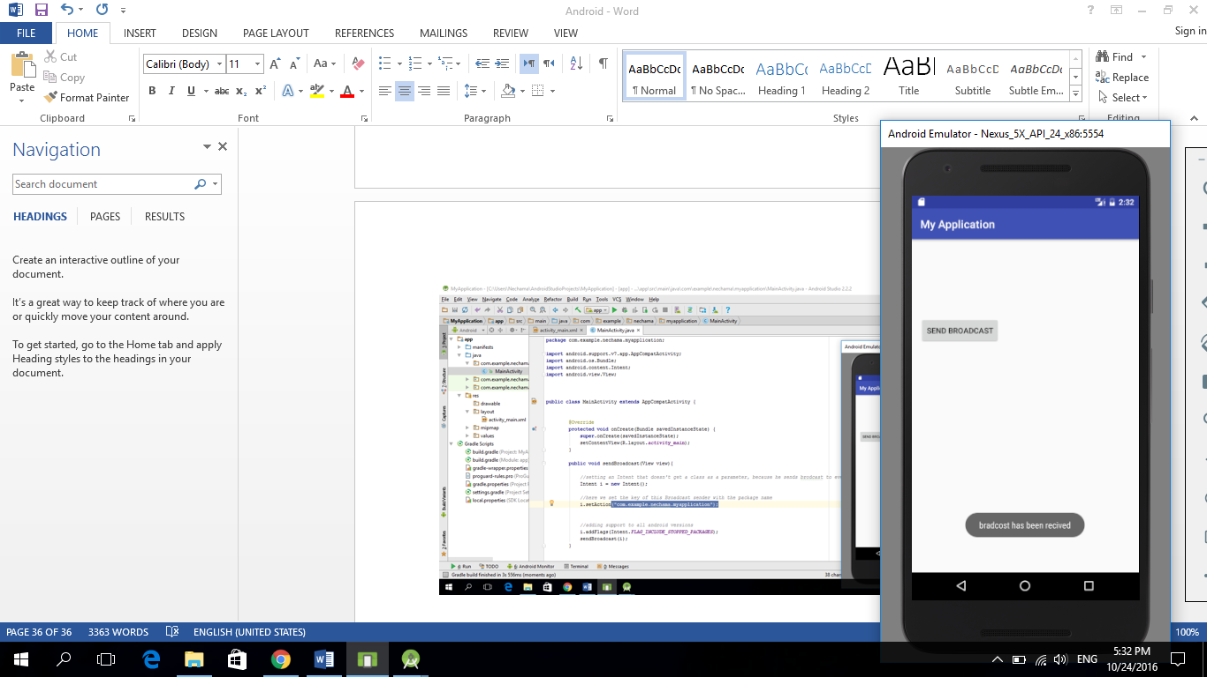 This in shown by

the receiver app

**Threads in android**

The threads are used to do actions in the background, without blocking the whole entire process.

Important: to change interface component from a thread we need to create a special handler.

In the following project we created an app that shows a popup message right after the click, and changes the text view content 10 seconds after the click.

Before clicking: right after clicking: 10 s after clicking:

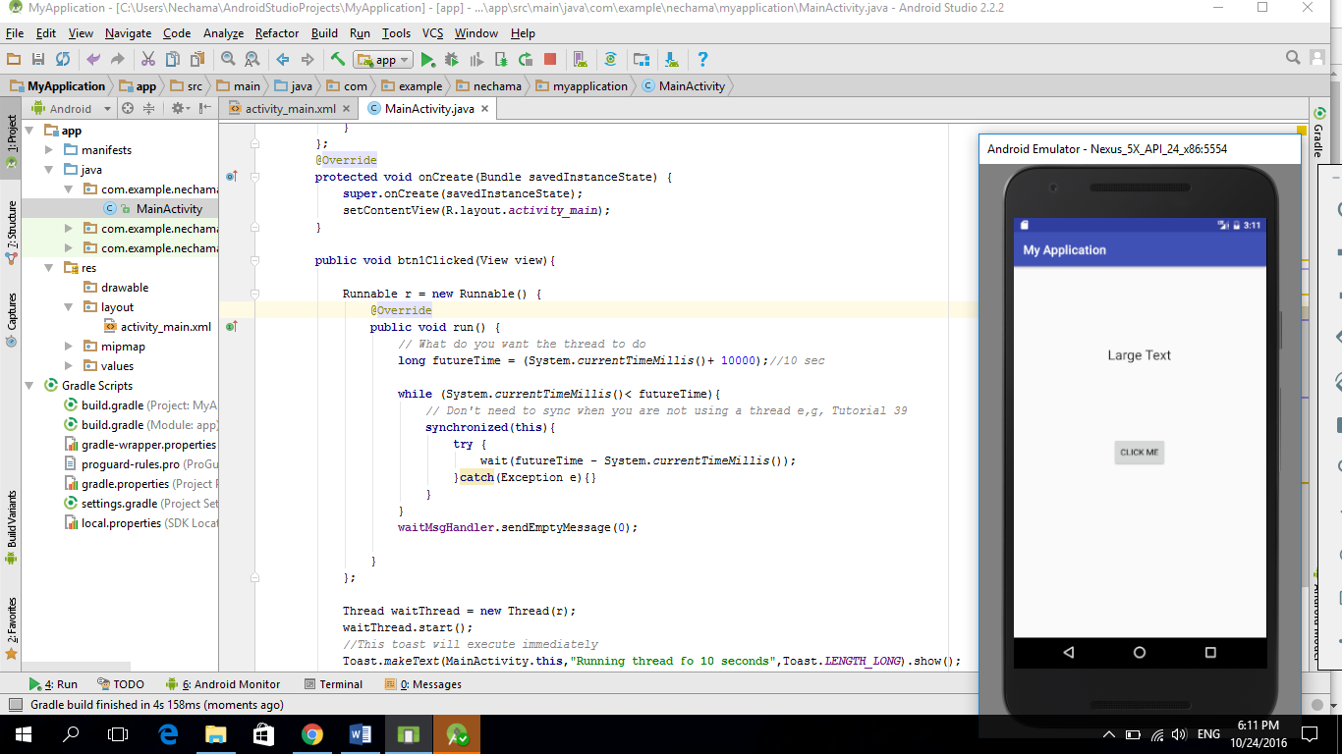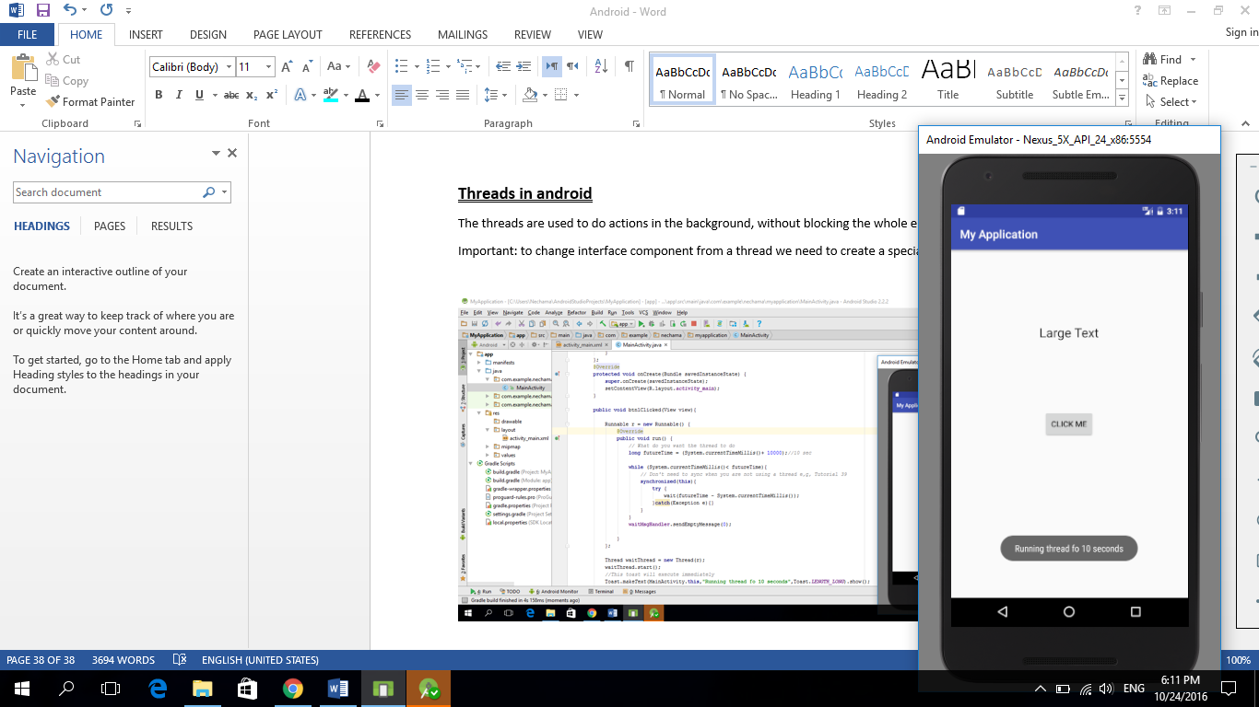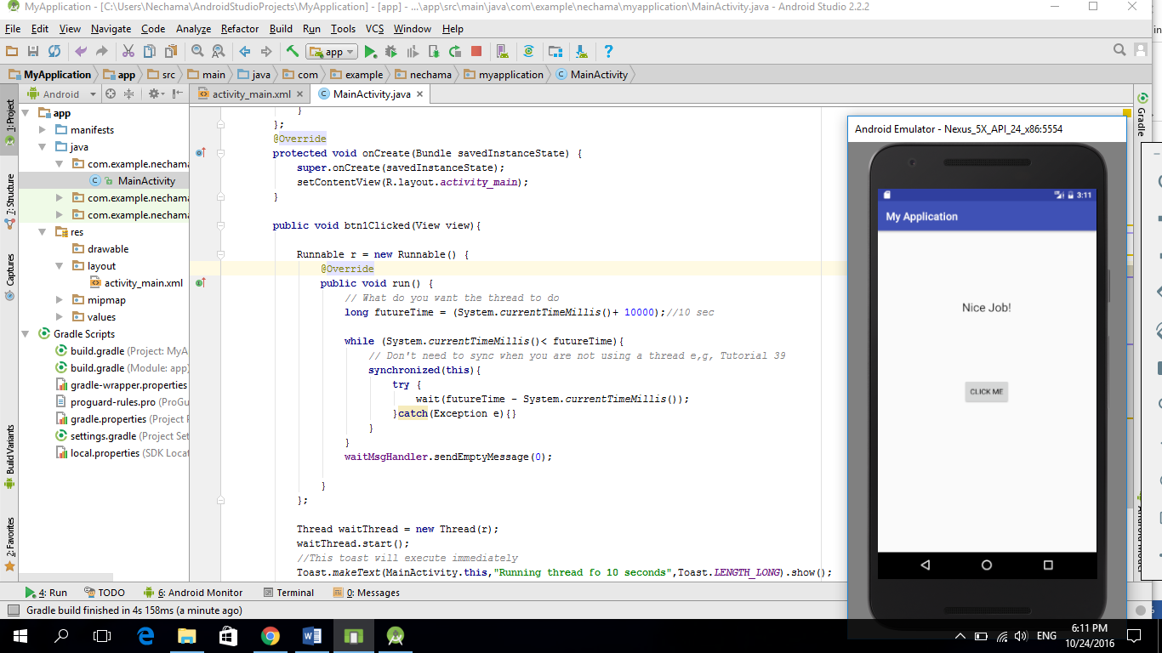

The java class:

**package** com.example.anna.myapplication;  
  
**import** android.support.v7.app.AppCompatActivity;  
**import** android.os.Bundle;  
**import** android.view.View;  
**import** android.os.Handler;  
**import** android.os.Message;  
**import** android.widget.TextView;  
**import** android.widget.Toast;  
  
  
  
**public class** MainActivity **extends** AppCompatActivity {  
  
 Handler **waitMsgHandler** = **new** Handler(){  
 @Override  
 **public void** handleMessage(Message msg) {  
 TextView tv1 = (TextView) findViewById(R.id.***tv1***);  
 tv1.setText(**"Nice Job!"**);  
 }  
 };  
 @Override  
 **protected void** onCreate(Bundle savedInstanceState) {  
 **super**.onCreate(savedInstanceState);  
 setContentView(R.layout.***activity_main***);  
 }  
  
 **public void** btn1Clicked(View view){  
  
 Runnable r = **new** Runnable() {

*//this function runs when we start the thread that stores this runnable object*  
 @Override  
 **public void** run() {**long** futureTime = (System.*currentTimeMillis*()+ 10000);*//10 sec* **while** (System.*currentTimeMillis*()< futureTime){**synchronized**(**this**){  
 **try** {  
 wait(futureTime - System.*currentTimeMillis*());  
 }**catch**(Exception e){}  
 }  
 }  
   
 *//updating the interface will be only trough a waitMsgHandler* **waitMsgHandler**.sendEmptyMessage(0);  
  
 }  
 };

*//here we initialized the thread object with the runnable object*

*//but we can also do it in a different way –creating an anonymous runnable class instead of passing a runnable object*   
 Thread waitThread = **new** Thread(r);

waitThread.start();  
 *//This toast will execute immediately* Toast.*makeText*(MainActivity.**this**,**"Running thread fo 10 seconds"**,Toast.***LENGTH_LONG***).show();  
  
}  
  
 }

The xml file:

*<?***xml version="1.0" encoding="utf-8"***?>*<**RelativeLayout xmlns:android="http://schemas.android.com/apk/res/android"  
 xmlns:tools="http://schemas.android.com/tools"  
 android:id="@+id/activity_main"  
 android:layout_width="match_parent"  
 android:layout_height="match_parent"  
 android:paddingBottom="@dimen/activity_vertical_margin"  
 android:paddingLeft="@dimen/activity_horizontal_margin"  
 android:paddingRight="@dimen/activity_horizontal_margin"  
 android:paddingTop="@dimen/activity_vertical_margin"  
 tools:context="com.example.anna.myapplication.MainActivity"**>  
  
 <**TextView  
 android:layout_width="wrap_content"  
 android:layout_height="wrap_content"  
 android:textAppearance="?android:attr/textAppearanceLarge"  
 android:text="Large Text"  
 android:id="@+id/tv1"  
 android:layout_alignParentTop="true"  
 android:layout_centerHorizontal="true"  
 android:layout_marginTop="112dp"** />  
  
 <**Button  
 android:layout_width="wrap_content"  
 android:layout_height="wrap_content"  
 android:text="Click Me"  
 android:id="@+id/btn1"  
 android:layout_centerVertical="true"  
 android:layout_centerHorizontal="true"  
 android:onClick="btn1Clicked"** />  
  
  
</**RelativeLayout**>

**Services**

Services - actions that are running in the background, and don’t have any interface.

(etc. downloading images).

Crating a service is in the following way:

Right click on the app directory, then:

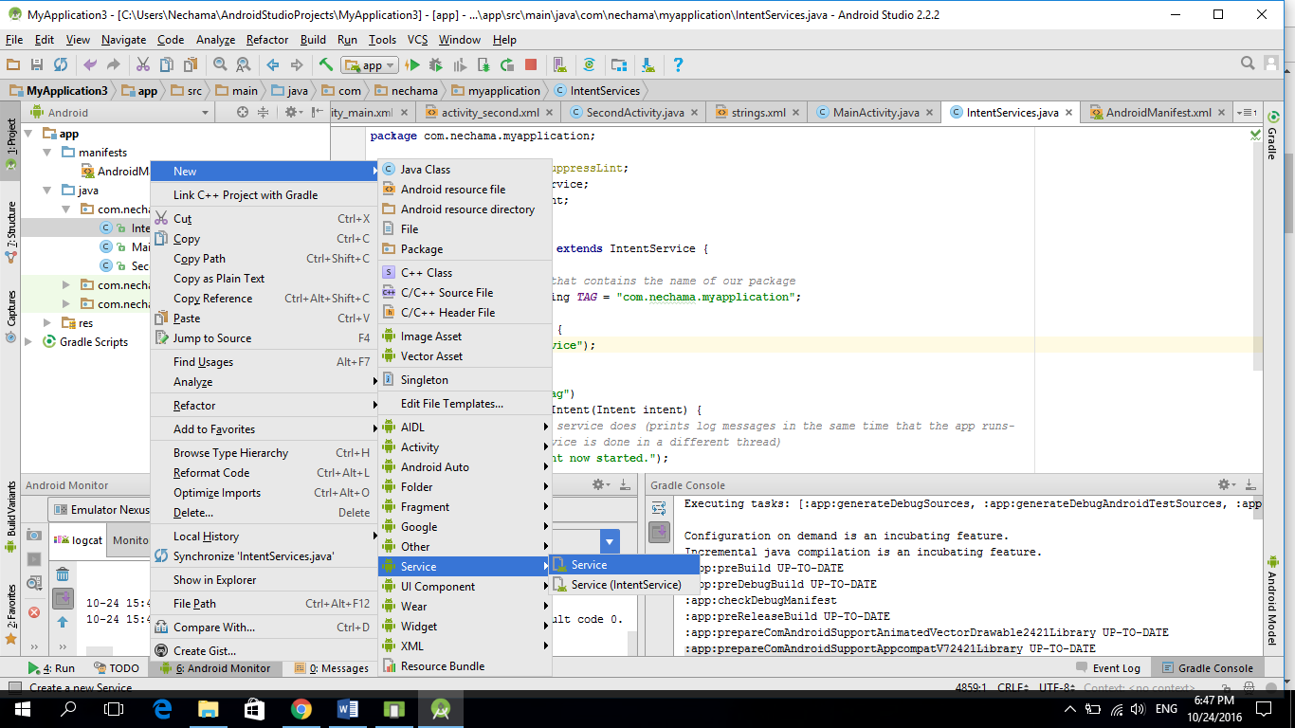

**Binding service to activity**

In the following example we created a service that returns the current time, and an activity that contains a button and a text view. Each click on the button sets the text view content to the current time according to the service information.

In order to insert the service data into an interface component (a service cant directly access the interface), we created a binder.

Before clicking: After clicking:

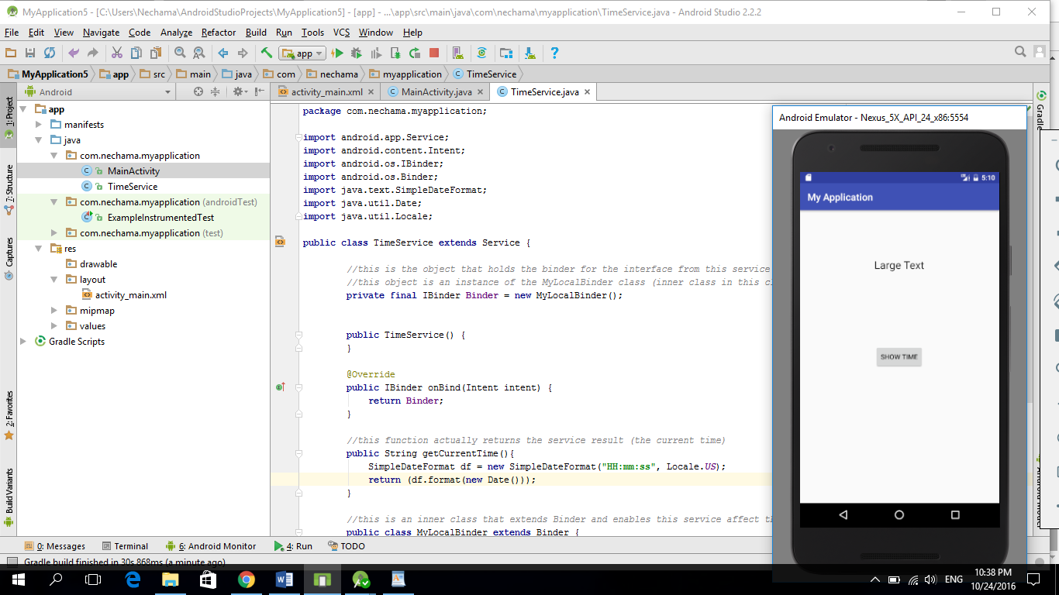 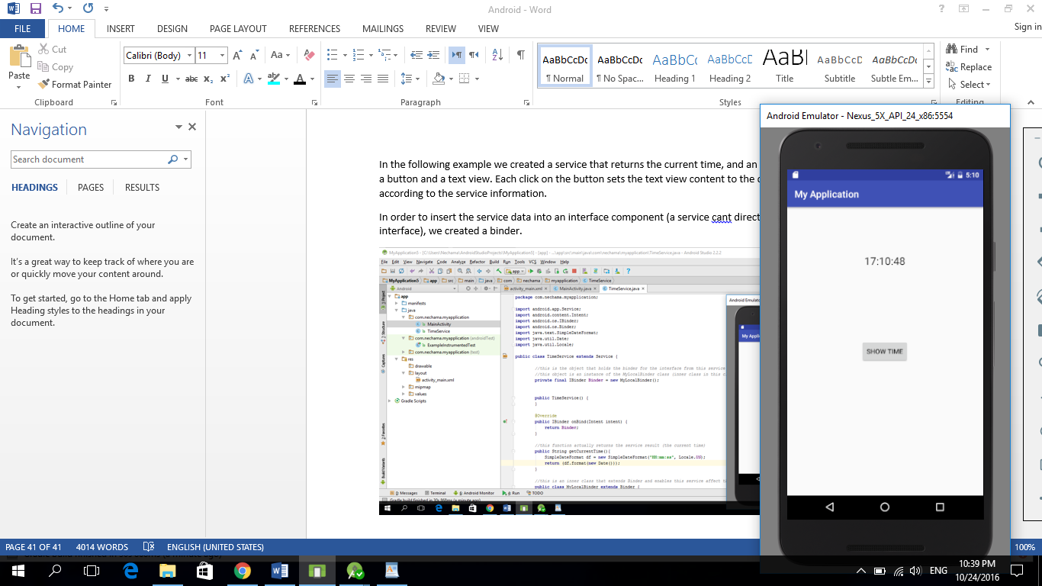

**Main activity code:**

**package** com.anna.myapplication;  
  
**import** android.support.v7.app.AppCompatActivity;  
**import** android.os.Bundle;  
**import** android.view.View;  
**import** android.widget.TextView;  
**import** android.os.IBinder;  
**import** android.content.Context;  
**import** android.content.Intent;  
**import** android.content.ComponentName;  
**import** android.content.ServiceConnection;  
**import** com.anna.myapplication.TimeService.MyLocalBinder;  
  
**public class** MainActivity **extends** AppCompatActivity {  
  
 TimeService **theService**;  
 **boolean isBound** = **false**;  
  
 **public void** btnShowTime(View view){  
   
 *//connecting to the service and getting the current time* String currentTime = **theService**.getCurrentTime();  
   
 *//setting the current time to the textview's content* TextView tvShowTime = (TextView) findViewById(R.id.***tvShowTime***);  
 tvShowTime.setText(currentTime);  
 }  
 @Override  
 **protected void** onCreate(Bundle savedInstanceState) {  
 **super**.onCreate(savedInstanceState);  
 setContentView(R.layout.***activity_main***);  
   
 *//here we create an instance to the TimeService* Intent i = **new** Intent(**this**, TimeService.**class**);  
   
 *//here we create the bind  
 //the 3 parameters are: the Intent, ServiceConnection, and Context.BIND_AUTO_CREATE)* bindService(i, **theConnection**, Context.***BIND_AUTO_CREATE***);  
  
 }  
  
 *//here we create a ServiceConnection that gives as access to the TimeService* **private** ServiceConnection **theConnection** = **new** ServiceConnection() {  
   
 @Override  
 **public void** onServiceConnected(ComponentName name, IBinder service) {  
 *// get a ref to the binder class and call the bind method* MyLocalBinder binder = (MyLocalBinder) service;  
 **theService** = binder.getService();  
 **isBound** = **true**;  
 }  
  
 @Override  
 **public void** onServiceDisconnected(ComponentName name) {  
 **isBound** = **false**;  
 }  
 };  
  
  
}

**main activity xml:**

<**RelativeLayout xmlns:android="http://schemas.android.com/apk/res/android"  
 xmlns:tools="http://schemas.android.com/tools"  
 android:id="@+id/activity_main"  
 android:layout_width="match_parent"  
 android:layout_height="match_parent"  
 android:paddingBottom="@dimen/activity_vertical_margin"  
 android:paddingLeft="@dimen/activity_horizontal_margin"  
 android:paddingRight="@dimen/activity_horizontal_margin"  
 android:paddingTop="@dimen/activity_vertical_margin"  
 tools:context="com.anna.myapplication.MainActivity"**>  
 <**TextView  
 android:layout_width="wrap_content"  
 android:layout_height="wrap_content"  
 android:textAppearance="?android:attr/textAppearanceLarge"  
 android:text="Large Text"  
 android:id="@+id/tvShowTime"  
 android:layout_alignParentTop="true"  
 android:layout_centerHorizontal="true"  
 android:layout_marginTop="81dp"** />  
  
 <**Button  
 android:layout_width="wrap_content"  
 android:layout_height="wrap_content"  
 android:text="Show Time"  
 android:id="@+id/btnShowTime"  
 android:onClick="btnShowTime"  
 android:layout_centerVertical="true"  
 android:layout_centerHorizontal="true"** />  
</**RelativeLayout**>

**TimeServise code:**

**package** com.anna.myapplication;  
  
**import** android.app.Service;  
**import** android.content.Intent;  
**import** android.os.IBinder;  
**import** android.os.Binder;  
**import** java.text.SimpleDateFormat;  
**import** java.util.Date;  
**import** java.util.Locale;  
  
**public class** TimeService **extends** Service {  
  
 *//this is the object that holds the binder for the interface from this service  
 //this object is an instance of the MyLocalBinder class (inner class in this class)* **private final** IBinder **Binder** = **new** MyLocalBinder();  
  
  
 **public** TimeService() {  
 }  
  
 @Override  
 **public** IBinder onBind(Intent intent) {  
 **return Binder**;  
 }  
  
 *//this function actually returns the service result (the current time)* **public** String getCurrentTime(){  
 SimpleDateFormat df = **new** SimpleDateFormat(**"HH:mm:ss"**, Locale.***US***);  
 **return** (df.format(**new** Date()));  
 }  
  
 *//this is an inner class that extends Binder and enables this service affect the interface* **public class** MyLocalBinder **extends** Binder {  
  
 *//this function returns a reference to this class, so we can use it's information* TimeService getService(){  
 **return** TimeService.**this**;  
 }  
 }  
  
 }

**Insert items into List view**

**The MainActivity code:**

**package** com.anna.myapplication;  
  
**import** android.support.v7.app.AppCompatActivity;  
**import** android.os.Bundle;  
**import** android.view.View;  
**import** android.widget.AdapterView;  
**import** android.widget.ArrayAdapter;  
**import** android.widget.ListAdapter;  
**import** android.widget.ListView;  
**import** android.widget.Toast;  
  
  
**public class** MainActivity **extends** AppCompatActivity {  
  
  
 @Override  
 **protected void** onCreate(Bundle savedInstanceState) {  
 **super**.onCreate(savedInstanceState);  
 setContentView(R.layout.***activity_main***);  
  
 *//crete string array* String[] foods = {**"banana"**, **"orange"**, **"cherry"**, **"apple"**, **"tomato"**, **"peach"**};  
  
 *//the parameter "android.R.layout.simple_list_item_1" is setting the list format design* ListAdapter MyAdapter = **new** ArrayAdapter<String>(**this**, android.R.layout.***simple_list_item_1***, foods);  
  
 *//getting the ListView component from the layout* ListView MyListView = (ListView) findViewById(R.id.***MyListView***);  
  
 *//adding the ListAdapter that we created to the ListView* MyListView.setAdapter(MyAdapter);  
  
 *//adding event listener to the ListView* MyListView.setOnItemClickListener(  
 *//On item click we will show to the screen a popup with the item's content* **new** AdapterView.OnItemClickListener(){  
 @Override  
 **public void** onItemClick(AdapterView<?> parent, View, **int** position, **long** id) {  
   
 String food = String.*valueOf*(parent.getItemAtPosition(position));  
 Toast.*makeText*(MainActivity.**this**, food, Toast.***LENGTH_LONG***).show();  
 }  
 }  
 );  
 }  
  
 }

**The xml file:**

*<?***xml version="1.0" encoding="utf-8"***?>*<**RelativeLayout xmlns:android="http://schemas.android.com/apk/res/android"  
 xmlns:tools="http://schemas.android.com/tools"  
 android:id="@+id/activity_main"  
 android:layout_width="match_parent"  
 android:layout_height="match_parent"  
 android:paddingBottom="@dimen/activity_vertical_margin"  
 android:paddingLeft="@dimen/activity_horizontal_margin"  
 android:paddingRight="@dimen/activity_horizontal_margin"  
 android:paddingTop="@dimen/activity_vertical_margin"  
 tools:context="com.anna.myapplication.MainActivity"**>  
 <**ListView  
 android:layout_width="match_parent"  
 android:layout_height="match_parent"  
 android:id="@+id/MyListView"**></**ListView**>  
  
</**RelativeLayout**>

**The result will be**

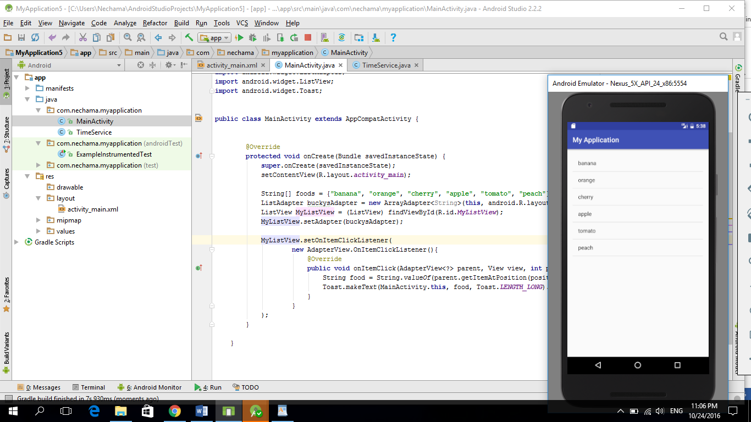

**After clicking on the “orange” item:**

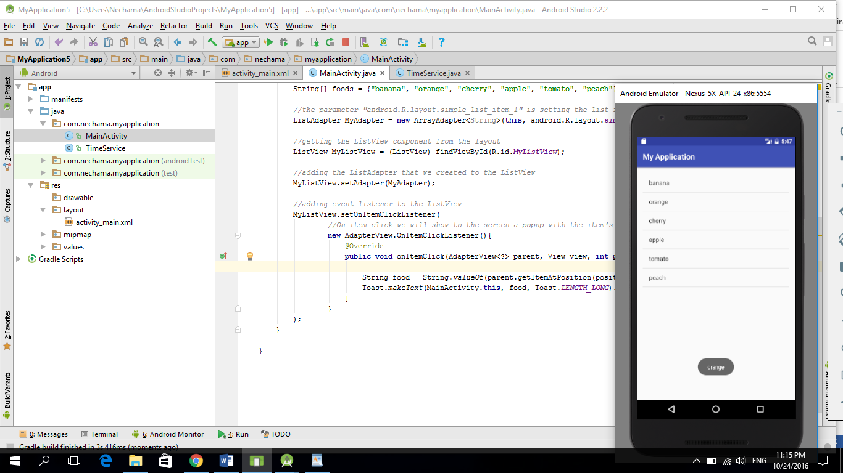

**Creating a customer list view**

In the following project we created a template of a list item in a separate xml file, and then creating a list view from the main activity, by setting each list item to the template list item.

(the template contains an image named “back” that we added to our project)

**The mainActivity code:**

**package** com.anna.myapplication;  
  
**import** android.support.v7.app.AppCompatActivity;  
**import** android.os.Bundle;  
**import** android.view.View;  
**import** android.widget.AdapterView;  
**import** android.widget.ArrayAdapter;  
**import** android.widget.ListAdapter;  
**import** android.widget.ListView;  
**import** android.widget.Toast;  
  
  
**public class** MainActivity **extends** AppCompatActivity {  
  
  
 @Override  
 **protected void** onCreate(Bundle savedInstanceState) {  
 **super**.onCreate(savedInstanceState);  
 setContentView(R.layout.***activity_main***);  
  
 *//crete string array* String[] foods = {**"banana"**, **"orange"**, **"cherry"**, **"apple"**, **"tomato"**, **"peach"**};  
  
  
 ListAdapter customListAdapter = **new** CustomAdapter(**this**,foods);*// Pass the food arrary to the constructor.* ListView customListView = (ListView) findViewById(R.id.***custom_ListView***);  
 customListView.setAdapter(customListAdapter);  
  
 *//adding event listener to the ListView* customListView.setOnItemClickListener(  
 *//On item click we will show to the screen a popup with the item's content* **new** AdapterView.OnItemClickListener(){  
 @Override  
 **public void** onItemClick(AdapterView<?> parent, View view, **int** position, **long** id) {  
  
 String food = String.*valueOf*(parent.getItemAtPosition(position));  
 Toast.*makeText*(MainActivity.**this**, food, Toast.***LENGTH_LONG***).show();  
 }  
 }  
 );  
 }  
  
 }

**The CustomAdapter** **code:**

**package** com.anna.myapplication;  
  
**import** android.content.Context;  
**import** android.view.LayoutInflater;  
**import** android.view.View;  
**import** android.view.ViewGroup;  
**import** android.widget.ArrayAdapter;  
**import** android.widget.ImageView;  
**import** android.widget.TextView;  
  
**class** CustomAdapter **extends** ArrayAdapter<String>{  
  
 **public** CustomAdapter(Context context, String[] foods) {  
 **super**(context, R.layout.***custom_row*** ,foods);  
 }  
  
 @Override  
 **public** View getView(**int** position, View convertView, ViewGroup parent) {  
  
 LayoutInflater myCustomInflater = LayoutInflater.*from*(getContext());  
 View customView = myCustomInflater.inflate(R.layout.***custom_row***, parent, **false**);  
  
 *// get references.* String singleFoodItem = getItem(position);  
 TextView itemText = (TextView) customView.findViewById(R.id.***item_text***);  
 ImageView itemImage = (ImageView) customView.findViewById(R.id.***my_profile_image***);  
  
 *// dynamically update the text from the array* itemText.setText(singleFoodItem);  
  
 *// using the same image every time* itemImage.setImageResource(R.drawable.***back***);  
  
 *// Now we can finally return our custom View or custom item* **return** customView;  
 }  
}

**The mainActivity xml:**

*<?***xml version="1.0" encoding="utf-8"***?>*<**RelativeLayout xmlns:android="http://schemas.android.com/apk/res/android"  
 xmlns:tools="http://schemas.android.com/tools"  
 android:id="@+id/activity_main"  
 android:layout_width="match_parent"  
 android:layout_height="match_parent"  
 android:paddingBottom="@dimen/activity_vertical_margin"  
 android:paddingLeft="@dimen/activity_horizontal_margin"  
 android:paddingRight="@dimen/activity_horizontal_margin"  
 android:paddingTop="@dimen/activity_vertical_margin"  
 tools:context="com.anna.myapplication.MainActivity"**>  
 <**ListView  
 android:layout_width="match_parent"  
 android:layout_height="match_parent"  
 android:id="@+id/custom_ListView"**></**ListView**>  
</**RelativeLayout**>

**The list-item xml:**

*<?***xml version="1.0" encoding="utf-8"***?>*<**LinearLayout xmlns:android="http://schemas.android.com/apk/res/android"  
 android:orientation="vertical" android:layout_width="match_parent"  
 android:layout_height="match_parent"**>  
  
 <**ImageView  
 android:layout_width="80dp"  
 android:layout_height="80dp"  
 android:id="@+id/my_profile_image"  
 android:src="@drawable/back"  
 android:layout_margin="5dp"** />  
  
  
 <**TextView  
 android:layout_width="wrap_content"  
 android:layout_height="wrap_content"  
 android:textAppearance="?android:attr/textAppearanceLarge"  
 android:text="Large Text"  
 android:id="@+id/item_text"  
 android:layout_margin="5dp"** />  
</**LinearLayout**>

**The result will be:**

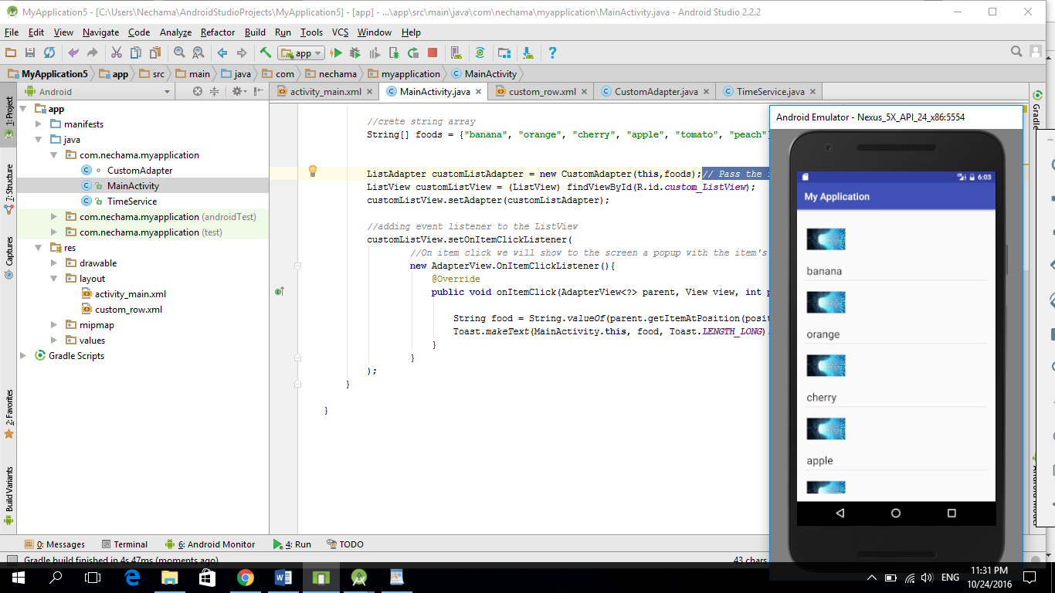

**After clicking on the “banana” item:**

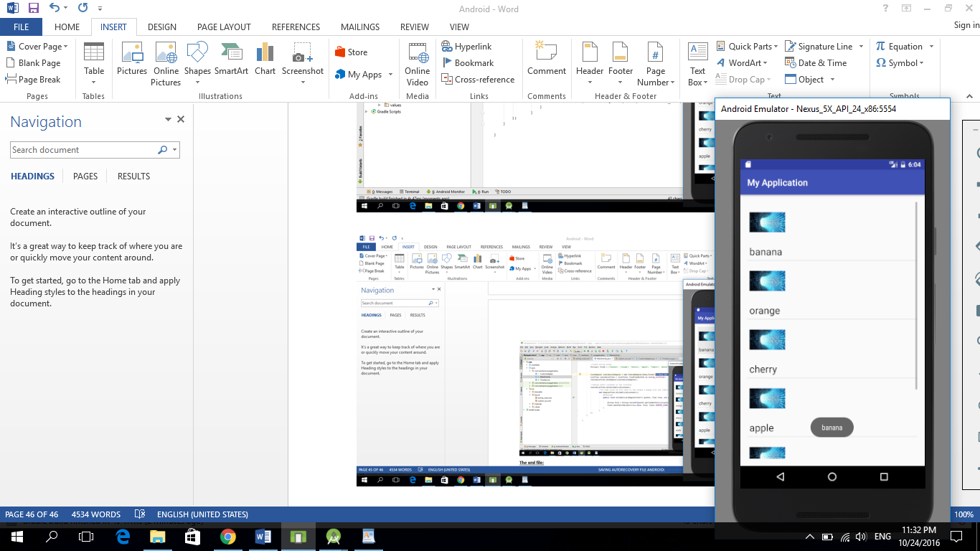

**Saving data in android DB**

Creating an app that allows to save products in the SQLite.

The user can add or delete products. And can see all the products that are stored in the DB.

The default activity on first run:

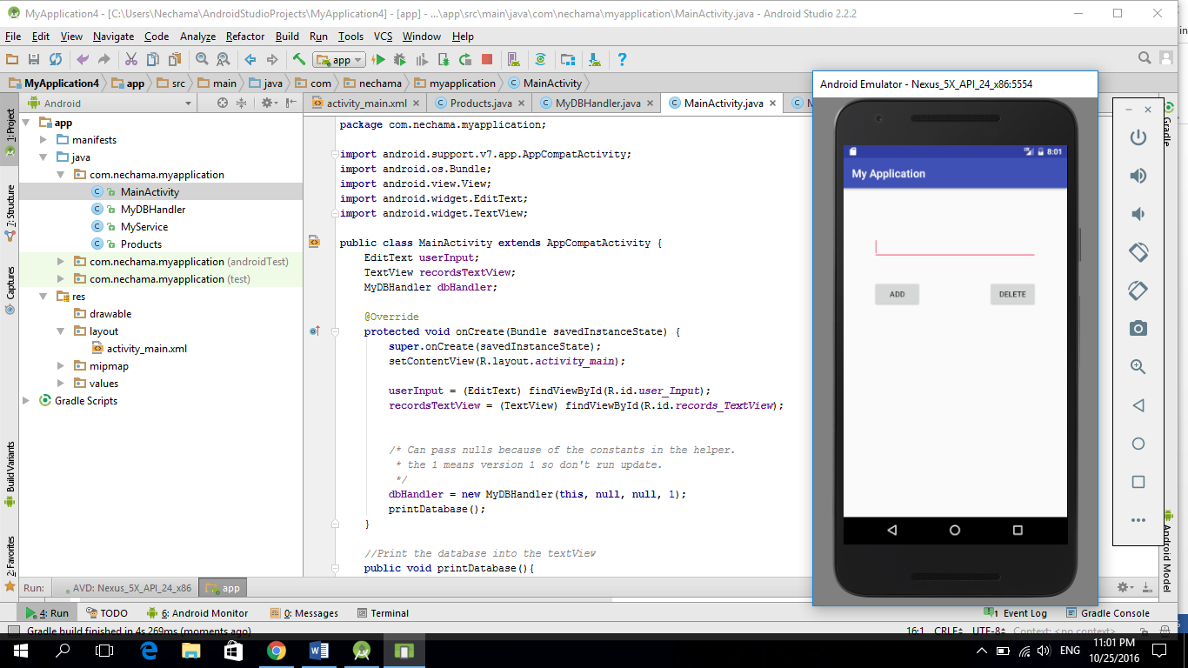

The activity after adding some products to the Db:

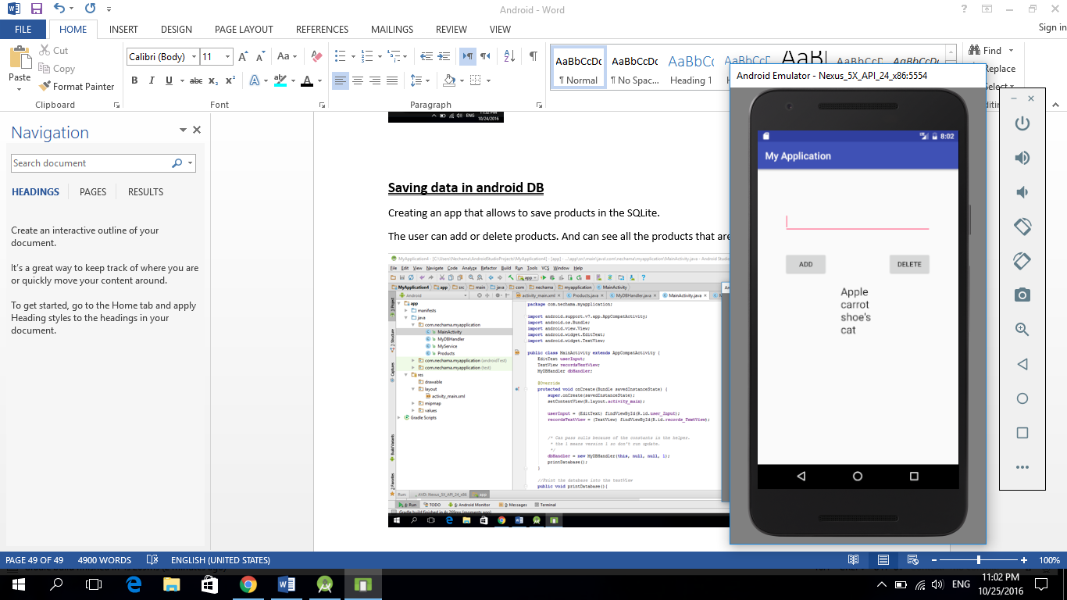

The activity after deleting the “Apple” product from Db:

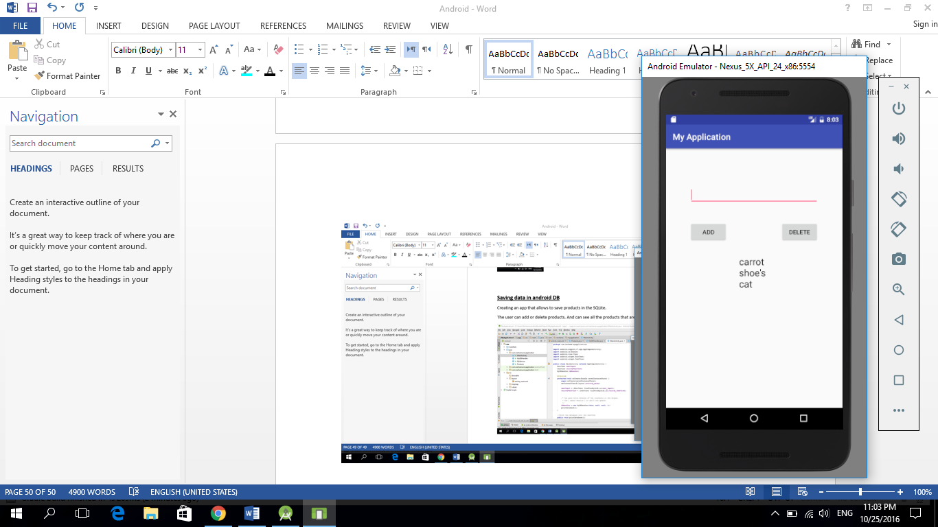

**Product class**

**package** com.anna.myapplication;  
  
*/**  
 * Created by Anna on 10/25/2016.  
 */***public class** Products {  
 **private int _id**;  
 **private** String **_productname**;  
  
 *//Added this empty constructor in case we ever want to create the object and assign it later.* **public** Products(){  
  
 }  
 **public** Products(String productName) {  
 **this**.**_productname** = productName;  
 }  
  
 **public int** get_id() {  
 **return _id**;  
 }  
  
 **public void** set_id(**int** _id) {  
 **this**.**_id** = _id;  
 }  
  
 **public** String get_productname() {  
 **return _productname**;  
 }  
  
 **public void** set_productname(String _productname) {  
 **this**.**_productname** = _productname;  
 }  
}

**Class MyDBHandler**

**package** com.anna.myapplication;  
**import** android.database.sqlite.SQLiteDatabase;  
**import** android.database.sqlite.SQLiteOpenHelper;  
**import** android.database.Cursor;  
**import** android.content.Context;  
**import** android.content.ContentValues;  
  
  
*//this class handles the all database tasks and extends the SQLiteOpenHelper (a build class)  
//in this class we must to implement the methods "onCreate" and "onUpgrade" from the SQLiteOpenHelper class***public class** MyDBHandler **extends** SQLiteOpenHelper{  
  
 **private static final int *DATABASE_VERSION*** = 1;  
 **private static final** String ***DATABASE_NAME*** = **"productDB.db"**;  
 **public static final** String ***TABLE_PRODUCTS*** = **"products"**;  
 **public static final** String ***COLUMN_ID*** = **"_id"**;  
 **public static final** String ***COLUMN_PRODUCTNAME*** = **"productname"**;  
  
  
 *//We need to pass database information along to superclass because the super class doesn't have any default constructor* **public** MyDBHandler(Context context, String name, SQLiteDatabase.CursorFactory factory, **int** version) {  
 **super**(context, ***DATABASE_NAME***, factory, ***DATABASE_VERSION***);  
 }  
  
 *//in the first time that we run this app we want to create our table in order to store data* @Override  
 **public void** onCreate(SQLiteDatabase db) {  
  
 *//every column is created by it's name, and by it's data type* String query = **"CREATE TABLE "** + ***TABLE_PRODUCTS*** + **"("** +  
 ***COLUMN_ID*** + **" INTEGER PRIMARY KEY AUTOINCREMENT, "** +  
 ***COLUMN_PRODUCTNAME*** + **" TEXT "** +  
 **");"**;  
  
 db.execSQL(query);  
 }  
  
 *//upgrade method is activated when we want to update our table  
 //first we delete our old table, and then we create a new table by calling the "onCreate" method* @Override  
 **public void** onUpgrade(SQLiteDatabase db, **int** oldVersion, **int** newVersion) {  
 db.execSQL(**"DROP TABLE IF EXISTS "** + ***TABLE_PRODUCTS***);  
 onCreate(db);  
 }  
  
 *//Add a new row to the database* **public void** addProduct(Products product){  
 ContentValues values = **new** ContentValues();  
 values.put(***COLUMN_PRODUCTNAME***, product.get_productname()); *//takes column's name and value* SQLiteDatabase db = getWritableDatabase(); *//here we get ref to our db* db.insert(***TABLE_PRODUCTS***, **null**, values);  
 db.close(); *//after adding a product we close the connection to the DB* }  
  
 *//Delete a product from the database* **public void** deleteProduct(String productName){  
 SQLiteDatabase db = getWritableDatabase();  
 db.execSQL(**"DELETE FROM "** + ***TABLE_PRODUCTS*** + **" WHERE "** + ***COLUMN_PRODUCTNAME*** + **"=\""** + productName + **"\";"**);  
 }  
  
 *// this is used in record_TextView in the Main activity, and returns a string that contains all product's information* **public** String databaseToString(){  
 String dbString = **""**;  
 SQLiteDatabase db = getWritableDatabase();  
 String query = **"SELECT * FROM "** + ***TABLE_PRODUCTS*** + **" WHERE 1"**; *// the condition "WHERE 1"  
  
 //Cursor can point to a row location in your results* Cursor recordSet = db.rawQuery(query, **null**);  
  
 *//Move to the first row in your results* recordSet.moveToFirst();  
  
 *//the loop will run while there are rows to read* **while** (!recordSet.isAfterLast()) {  
  
 *// null could happen if we used our empty constructor* **if** (recordSet.getString(recordSet.getColumnIndex(**"productname"**)) != **null**) {  
 dbString += recordSet.getString(recordSet.getColumnIndex(**"productname"**));  
 dbString += **"\n"**;  
 }  
 recordSet.moveToNext();  
 }  
 db.close();  
 **return** dbString;  
 }  
  
}

**MainActivity class**

**package** com.anna.myapplication;  
  
**import** android.support.v7.app.AppCompatActivity;  
**import** android.os.Bundle;  
**import** android.view.View;  
**import** android.widget.EditText;  
**import** android.widget.TextView;  
  
**public class** MainActivity **extends** AppCompatActivity {  
 EditText **userInput**;  
 TextView **recordsTextView**;  
 MyDBHandler **dbHandler**;  
  
 @Override  
 **protected void** onCreate(Bundle savedInstanceState) {  
 **super**.onCreate(savedInstanceState);  
 setContentView(R.layout.***activity_main***);  
  
 **userInput** = (EditText) findViewById(R.id.***user_Input***);  
 **recordsTextView** = (TextView) findViewById(R.id.***records_TextView***);  
  
  
 */* Can pass nulls because of the constants in the helper.  
 * the 1 means version 1 so don't run update.  
 */* **dbHandler** = **new** MyDBHandler(**this**, **null**, **null**, 1);  
 printDatabase();  
 }  
  
 *//Print the database into the textView* **public void** printDatabase(){  
 String dbString = **dbHandler**.databaseToString();  
 **recordsTextView**.setText(dbString);  
 **userInput**.setText(**""**);  
 }  
  
 *//add your elements onclick methods.  
 //Add a product to the database* **public void** addButtonClicked(View view){  
  
 *// dbHandler.add needs an product parameter.* Products product = **new** Products(**userInput**.getText().toString());  
 **dbHandler**.addProduct(product);  
 printDatabase(); *//updates the output list* }  
  
 *//Delete items* **public void** deleteButtonClicked(View view){  
 *// dbHandler delete needs string to find in the db* String inputText = **userInput**.getText().toString();  
 **dbHandler**.deleteProduct(inputText);  
 printDatabase(); *//updates the output list* }  
  
}

**MainActivity xml**

*<?***xml version="1.0" encoding="utf-8"***?>*<**RelativeLayout xmlns:android="http://schemas.android.com/apk/res/android"  
 xmlns:tools="http://schemas.android.com/tools"  
 android:id="@+id/activity_main"  
 android:layout_width="match_parent"  
 android:layout_height="match_parent"  
 android:paddingBottom="@dimen/activity_vertical_margin"  
 android:paddingLeft="@dimen/activity_horizontal_margin"  
 android:paddingRight="@dimen/activity_horizontal_margin"  
 android:paddingTop="@dimen/activity_vertical_margin"  
 tools:context="com.anna.myapplication.MainActivity"**>  
  
 <**EditText  
 android:layout_width="wrap_content"  
 android:layout_height="wrap_content"  
 android:id="@+id/user_Input"  
 android:layout_alignParentTop="true"  
 android:layout_centerHorizontal="true"  
 android:layout_marginTop="69dp"  
 android:width="300dp"** />  
  
 <**Button  
 android:layout_width="wrap_content"  
 android:layout_height="wrap_content"  
 android:text="Add"  
 android:id="@+id/add_Button"  
 android:layout_below="@+id/user_Input"  
 android:layout_alignStart="@+id/user_Input"  
 android:layout_marginTop="40dp"  
 android:onClick="addButtonClicked"** />  
  
 <**Button  
 android:layout_width="wrap_content"  
 android:layout_height="wrap_content"  
 android:text="Delete"  
 android:id="@+id/delete_Button"  
 android:layout_alignTop="@+id/add_Button"  
 android:layout_alignEnd="@+id/user_Input"  
 android:onClick="deleteButtonClicked"** />  
  
 <**TextView  
 android:layout_width="wrap_content"  
 android:layout_height="wrap_content"  
 android:textAppearance="?android:attr/textAppearanceLarge"  
 android:text="Large Text"  
 android:id="@+id/records_TextView"  
 android:layout_centerVertical="true"  
 android:layout_centerHorizontal="true"** />  
</**RelativeLayout**>

**Adding video to an activity**

In order to add a video to our app according to the following code, we need to set the project’s version, to minimum 15’s version.

**MainActivity Class:**

**package** com.anna.myapplication;  
  
**import** android.support.v7.app.AppCompatActivity;  
**import** android.os.Bundle;  
**import** android.widget.VideoView;  
**import** android.widget.MediaController;  
  
**public class** MainActivity **extends** AppCompatActivity {  
  
  
 @Override  
 **protected void** onCreate(Bundle savedInstanceState) {  
 **super**.onCreate(savedInstanceState);  
 setContentView(R.layout.***activity_main***);  
  
 **final** VideoView myVideoView = (VideoView) findViewById(R.id.***MyVideoView***);  
 myVideoView.setVideoPath(**"testVideo.mp4"**);  
  
 *//Player controls(play, pause, stop, etc...)* MediaController = **new** MediaController(**this**);  
 mediaController.setAnchorView(myVideoView);  
 myVideoView.setMediaController(mediaController);  
  
 myVideoView.start();  
 }  
  
 }

**xml file:**

*<?***xml version="1.0" encoding="utf-8"***?>*<**RelativeLayout xmlns:android="http://schemas.android.com/apk/res/android"  
 xmlns:tools="http://schemas.android.com/tools"  
 android:id="@+id/activity_main"  
 android:layout_width="match_parent"  
 android:layout_height="match_parent"  
 android:paddingBottom="@dimen/activity_vertical_margin"  
 android:paddingLeft="@dimen/activity_horizontal_margin"  
 android:paddingRight="@dimen/activity_horizontal_margin"  
 android:paddingTop="@dimen/activity_vertical_margin"  
 tools:context="com.anna.myapplication.MainActivity"**>  
  
 <**VideoView  
 android:layout_width="wrap_content"  
 android:layout_height="wrap_content"  
 android:id="@+id/MyVideoView"** />  
</**RelativeLayout**>

**Controlling the device’s camera**

We created an activity with a button that onclick opens the mobile’s camera, and then displays the taken image inside an image view.

In order to enable our app to use the camera we need to add in the mainfast:

<**uses-feature android:name="android.hardware.Camera" android:required="true"**></**uses-feature**>

Before clicking the button:

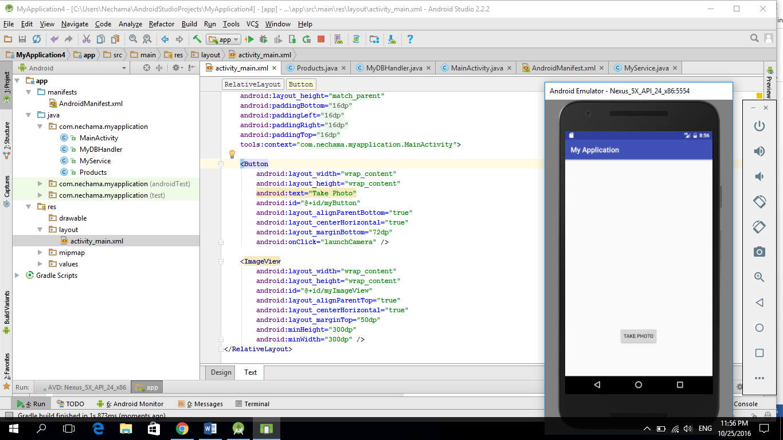

After clicking the button: (the camera is on)

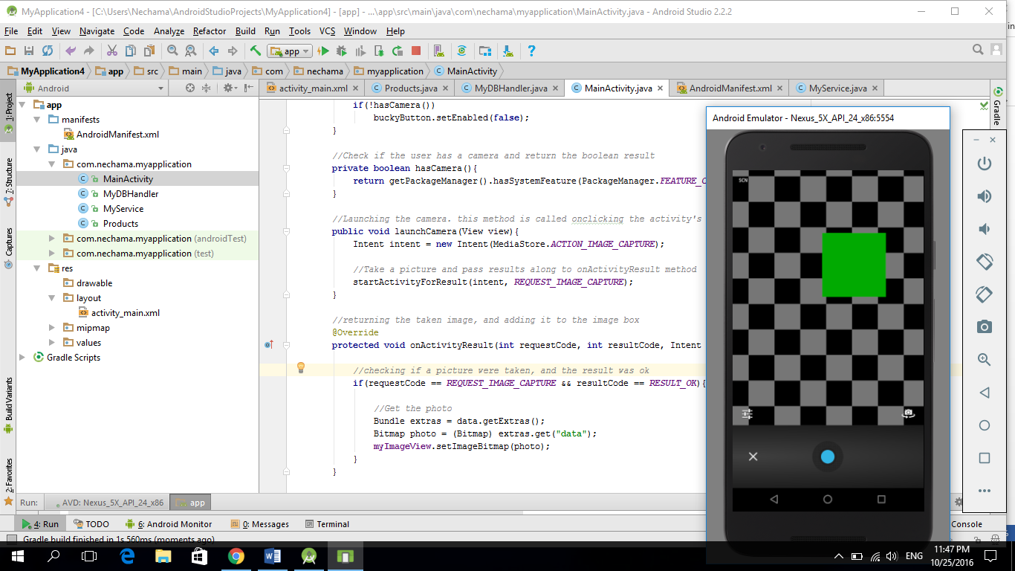

After taking a picture: (the image is displayed in the image box)

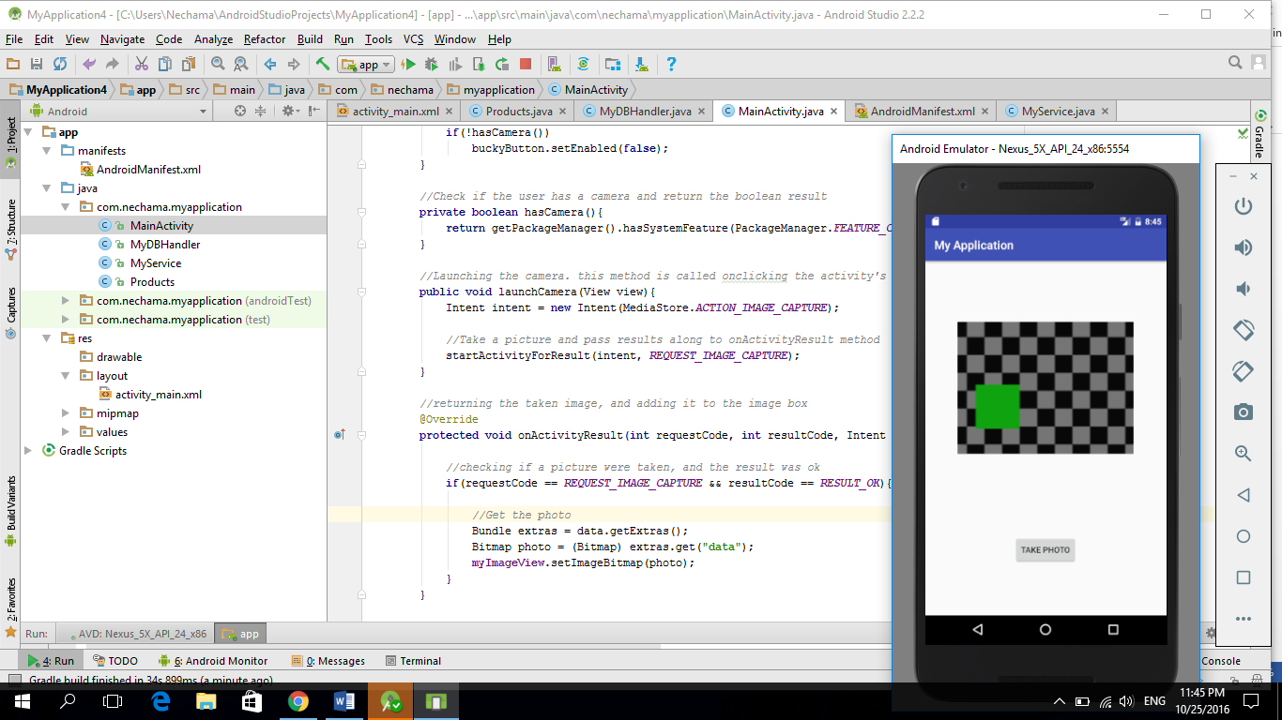

**MainActivity class:**

**package** com.anna.myapplication;  
  
**import** android.support.v7.app.AppCompatActivity;  
**import** android.os.Bundle;  
**import** android.content.Intent;  
**import** android.content.pm.PackageManager;  
**import** android.graphics.Bitmap;  
**import** android.provider.MediaStore;  
**import** android.view.View;  
**import** android.widget.Button;  
**import** android.widget.ImageView;  
  
**public class** MainActivity **extends** AppCompatActivity {  
  
 *//a way to adentify each intent (if we use different intents in the app)* **static final int *REQUEST_IMAGE_CAPTURE*** = 1;  
 ImageView **myImageView**;  
  
 @Override  
 **protected void** onCreate(Bundle savedInstanceState) {  
 **super**.onCreate(savedInstanceState);  
 setContentView(R.layout.***activity_main***);  
  
 Button buckyButton = (Button) findViewById(R.id.***myButton***);  
 **myImageView** = (ImageView) findViewById(R.id.***myImageView***);  
  
 *//Disable the button if the user's device has no camera* **if**(!hasCamera())  
 buckyButton.setEnabled(**false**);  
 }  
  
 *//Check if the user has a camera and return the boolean result* **private boolean** hasCamera(){  
 **return** getPackageManager().hasSystemFeature(PackageManager.***FEATURE_CAMERA_ANY***);  
 }  
  
 *//Launching the camera. this method is called onclicking the activity's button* **public void** launchCamera(View view){  
 Intent intent = **new** Intent(MediaStore.***ACTION_IMAGE_CAPTURE***);  
  
 *//Take a picture and pass results along to onActivityResult method* startActivityForResult(intent, ***REQUEST_IMAGE_CAPTURE***);  
 }  
  
 *//returning the taken image, and adding it to the image box* @Override  
 **protected void** onActivityResult(**int** requestCode, **int** resultCode, Intent data) {  
  
 *//checking if a picture were taken, and the result was ok* **if**(requestCode == ***REQUEST_IMAGE_CAPTURE*** && resultCode == ***RESULT_OK***){  
  
 *//Get the photo* Bundle extras = data.getExtras();  
 Bitmap photo = (Bitmap) extras.get(**"data"**);  
 **myImageView**.setImageBitmap(photo);  
 }  
 }  
  
 }

**MainActivity xml:**

*<?***xml version="1.0" encoding="utf-8"***?>*<**RelativeLayout xmlns:android="http://schemas.android.com/apk/res/android"  
 xmlns:tools="http://schemas.android.com/tools"  
 android:id="@+id/activity_main"  
 android:layout_width="match_parent"  
 android:layout_height="match_parent"  
 android:paddingBottom="@dimen/activity_vertical_margin"  
 android:paddingLeft="@dimen/activity_horizontal_margin"  
 android:paddingRight="@dimen/activity_horizontal_margin"  
 android:paddingTop="@dimen/activity_vertical_margin"  
 tools:context="com.anna.myapplication.MainActivity"**>  
  
 <**Button  
 android:layout_width="wrap_content"  
 android:layout_height="wrap_content"  
 android:text="Take Photo"  
 android:id="@+id/myButton"  
 android:layout_alignParentBottom="true"  
 android:layout_centerHorizontal="true"  
 android:layout_marginBottom="72dp"  
 android:onClick="launchCamera"** />  
  
 <**ImageView  
 android:layout_width="wrap_content"  
 android:layout_height="wrap_content"  
 android:id="@+id/myImageView"  
 android:layout_alignParentTop="true"**

**android:layout_centerHorizontal="true"  
 android:layout_marginTop="50dp"  
 android:minHeight="300dp"  
 android:minWidth="300dp"** />  
</**RelativeLayout**>

**Mainfest:**

*<?***xml version="1.0" encoding="utf-8"***?>*<**manifest xmlns:android="http://schemas.android.com/apk/res/android"  
 package="com.anna.myapplication"**>  
<**uses-feature android:name="android.hardware.Camera" android:required="true"**></**uses-feature**>  
 <**application  
 android:allowBackup="true"  
 android:icon="@mipmap/ic_launcher"  
 android:label="@string/app_name"  
 android:supportsRtl="true"  
 android:theme="@style/AppTheme"**>  
 <**activity android:name=".MainActivity"**>  
 <**intent-filter**>  
 <**action android:name="android.intent.action.MAIN"** />  
  
 <**category android:name="android.intent.category.LAUNCHER"** />  
 </**intent-filter**>  
 </**activity**>  
  
 <**service  
 android:name=".MyService"  
 android:enabled="true"  
 android:exported="true"**></**service**>  
 </**application**>  
  
</**manifest**>

**Notification**

**MainActivity class:**

**package** com.anna.myapplication;  
  
**import** android.support.v7.app.AppCompatActivity;  
**import** android.os.Bundle;  
**import** android.content.Intent;  
**import** android.view.View;  
**import** android.app.NotificationManager;  
**import** android.app.PendingIntent;  
**import** android.support.v4.app.NotificationCompat;  
  
  
**public class** MainActivity **extends** AppCompatActivity {  
  
 NotificationCompat.Builder **notification**;  
  
 **private static final int *uniqueID*** = 45612; *//the uniqueID is a number that we chose* **protected void** onCreate(Bundle savedInstanceState) {  
 **super**.onCreate(savedInstanceState);  
 setContentView(R.layout.***activity_main***);  
  
 **notification** = **new** NotificationCompat.Builder(**this**);  
  
 *//here we cancel the notification that was displayed in the user's screen  
 //because after a user clicks on the notification he* **notification**.setAutoCancel(**true**);  
 }  
  
 **public void** ButtonClicked(View view){  
 *//Build the notification* **notification**.setSmallIcon(R.mipmap.***ic_launcher***);  
  
 *//this is the text that appers when the notification appears* **notification**.setTicker(**"This is the ticker"**);  
  
 *//this setts the time that will appear on the notification (as a receive time)* **notification**.setWhen(System.*currentTimeMillis*());  
  
 **notification**.setContentTitle(**"the notification's title"**);  
 **notification**.setContentText(**"body text notification"**);  
  
 *//here we create an intent, and send the class of the activity that we want to access by the notification* Intent intent = **new** Intent(**this**, MainActivity.**class**);  
  
 *//gives our app an access to the device's home screen* PendingIntent pendingIntent = PendingIntent.*getActivity*(**this**, 0, intent, PendingIntent.***FLAG_UPDATE_CURRENT***);  
  
 **notification**.setContentIntent(pendingIntent);  
  
 *//Builds notification and issues it* NotificationManager nm = (NotificationManager) getSystemService(***NOTIFICATION_SERVICE***);  
 nm.notify(***uniqueID***, **notification**.build());  
  
 }  
  
 }

**MainActivity xml:**

*<?***xml version="1.0" encoding="utf-8"***?>*<**RelativeLayout xmlns:android="http://schemas.android.com/apk/res/android"  
 xmlns:tools="http://schemas.android.com/tools"  
 android:id="@+id/activity_main"  
 android:layout_width="match_parent"  
 android:layout_height="match_parent"  
 android:paddingBottom="@dimen/activity_vertical_margin"  
 android:paddingLeft="@dimen/activity_horizontal_margin"  
 android:paddingRight="@dimen/activity_horizontal_margin"  
 android:paddingTop="@dimen/activity_vertical_margin"  
 tools:context="com.anna.myapplication.MainActivity"**>  
  
 <**Button  
 android:layout_width="wrap_content"  
 android:layout_height="wrap_content"  
 android:text="Click for Notification"  
 android:id="@+id/Button1"  
 android:layout_centerVertical="true"  
 android:layout_centerHorizontal="true"  
 android:onClick="ButtonClicked"** />  
</**RelativeLayout**>

**The result by default**

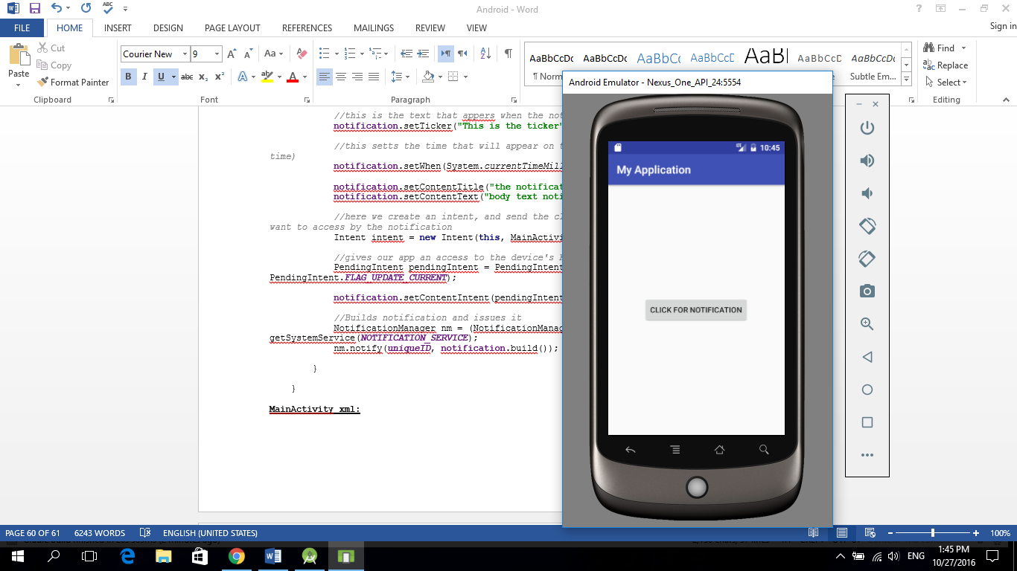

**The result after clicking the activities’ button**

